Sarah Horton
The Lion King? Drawings of the lion garden ornament

Abstract
Exploring the lion as a symbol of England’s colonial past the drawings presented in this research project seek to subvert the idea of the lion as a symbol of power through the decorative interventions applied to them. The history of the lion as a symbol of British identity and strength in public monuments such as Trafalgar Square is compared to the ways in which owners of ordinary suburban housing in England use lion garden ornaments as indicators of habitus, or class, (Bourdieu) and conspicuous consumption (Veblen). The act of drawing brings these ornaments into the ownership of the artist who employs a number of decorative interventions that seek to undermine the lion’s symbolic status. This is a speculative set of work created during the limbo of Britain’s Brexit negotiations in 2019. It has potential implications for anyone researching the relationship between ornament and identity, or drawing and ornament.

Key words: lions, drawing, colonialism, ornament, Africa, interventions, Bourdieu, Veblen

Introduction
This research project features a set of drawings that use depictions of lion ornaments found in suburban gardens. Exploring the lion as a symbol of England’s colonial past the drawings seek to subvert the idea of the lion as a symbol of power through the decorative interventions applied to them in the drawings. Thus, the research question being addressed is to what extent the depiction of the lion in artworks derived from photographs of lion statuary can be used to subvert notions of power when used with pattern and decoration? This is a speculative set of work created during the limbo of Britain’s Brexit negotiations in 2019. It has potential implications for anyone researching the relationship between ornament and identity, or drawing and ornament.

Many inhabitants of England will recognise the lion as a symbol of ‘Englishness’. The lion and the unicorn are on the UK’s heraldic coat of arms, where the lion represents England and the unicorn Scotland. The combination of the lion and the unicorn dates back to the accession of the throne in 1603 of James 1 of England. There is evidence that the depiction of the lion alone goes back to the 12th century when three golden lions against a red background were used on standards carried to inspire soldiers in battle (Fox-Davis 2008; Ingle 2002). Lions still feature against a red background on England’s Royal Arms and, perhaps most famously, three lions represent England’s football and cricket teams.

Although the broader symbolism of the lion is highly complex the lion (for it is rarely the lioness) appears in a myriad of myths, stories and religions as a figure of physical and divine strength, of nobility and security. It is not difficult to see why the figure of the lion is appropriated for these circumstances and nowhere is the spectacle of grandeur more obvious than in London’s Trafalgar Square where Edwin Landseer‘s four gargantuan lions sit at the foot of Nelson’s column.

Signs of conspicuous consumption
The lion ornaments featured in the drawings for this research were all observed in the front gardens or on the gateposts of suburban domestic houses in the city of Norwich, England in a mix of large and small terraced and detached properties. Through their placement at each address there is a sense of the ornaments being used to mark the boundaries of each home. Sociologist George Simmel wrote that ‘the boundary is not a spatial fact with sociological consequences, but a sociological fact that forms itself socially’ (Simmel 1997: 143). The very deliberate placement of the lion statues was designed to reinforce a demarcation of property boundaries. Although the size of the statues ranged from 30cm to 120cm in height they were all placed prominently in the front garden, flanking the front door or balanced on the garden wall alongside the entrance to the drive or garden path. Whatever their size or location, the posture of the lions, whether assuming an upright or prone position, had raised heads (couchant) as if acting as guardians or sentinels marking the boundaries of the properties they defended. These lions, especially those elevated onto brick pillars as the lions that feature in Figures 1 and 2, ‘announced’ to the world that these premises could not be penetrated easily.

House and garden furnishings are just some of the factors identified by French sociologist Pierre Bourdieu when outlining the extensive analysis of signifiers that, for him, characterize class and identity within the everyday. In Distinction: A Social Critique of the Judgement of Taste (1979) Bourdieu states that the ordinary choices of the everyday such as furniture and clothing are particularly revealing of deep-rooted and long-standing dispositions that ‘forge the unconscious unity of a class’ (Bourdieu 1979: 77) A person’s preferences and dispositions are described by Bourdieu as the individual’s ‘habitus’ which, when combined with the different fields within which people operate (education, the workplace, social groups and so on) define a person’s class (Bourdieu 1979: 226).

This can be usefully applied to the display of these lion ornaments and how they may be used by their owners to indicate a sense of identity or status. Bourdieu identifies four forms of capital that characterize class position: economic capital, cultural capital, social capital and symbolic capital. Individuals are grouped not only by their social class but every kind of capital available to them. Symbolic capital describes a field within which any set of objects or types of activity can be judged by or through socially generated systems of classification and can be seen as a source of power; or the values of prestige, status and other forms of social honour that enable those with high status to control or dominate those with lower status.

Life-styles are thus the systematic products of habitus, which, perceived in their mutual relations through the schemes of the habitus, become sign systems that are socially qualified (as ‘distinguished’, ‘vulgar’ etc.). The dialectic of conditions and habitus is the basis of an alchemy which transforms the distribution of capital, the balance-sheet of a power relation, into a system of perceived differences, distinctive properties, that is, a distribution of symbolic capital…. (Bourdieu 1979: 172).

Bourdieu’s thesis was grounded in Thorstein Veblen’s theory of conspicuous consumption (1899). Conspicuous consumption describes the way in which outward signs of wealth, for example excessive giving of presents or entertainments, the wearing of lavish clothes or purchasing of expensive goods, are made for the express purpose of signifying the owner’s wealth and status. Taking the theses of Bourdieu and Veblen together the acquisition of objects can say something about the status, wealth, attitudes or values of that individual.

Isabella Graw pairs the concept of the ‘symbolic’ as used by Bourdieu with a Marxian concept of ‘value’ in the context of the commodity when she writes:

‘(S)ymbolic value may be defined as a dual social charge, a charge that is conveyed by specific symbol-bearers but cannot be apprehended in terms of these bearers themselves. It stands for a surplus and an assumption of meaning and worth that goes beyond the concrete object used to refer it’. (Graw 2010: 23)

This is where the link between Bourdieu and Veblen becomes even more applicable: the lion ornaments attract cachet by association. The surplus meaning that arises through the display of these ornaments is arrived at by connotations of grandeur recognised in the lion emblem in prominent public spaces such as Trafalgar Square or in the iconography of heraldry and national insignia and applied in the choice of these ornaments.

Appropriation
Of particular importance to Veblen is the visibility of objects and it is the prominent display of these ornaments that asserts their intention to impress. The lions, however fierce they may be in the wild, and unlike their counterpart, the domestic cat, are in the case of these statues, static and unmoving. Although they may be used as symbols of impenetrability and may appear to see all, they actually see nothing. The lions in the drawings are doubly tamed: their
stone bodies are captured and stilled through my drawing of them.

By drawing the lions I am appropriating them, the process of transcription laying claim to them. The etymology of the word appropriate comes from the Latin word propriare meaning ‘to take as one’s own’ (etymonline nd). The process of transcription is to rewrite in a different script, this ‘rewriting’ using a process of mimesis, a translation of the three-dimensional form onto the page. Tania Kovats takes the meaning of the word ‘draw’ as a means to delineate, and to extract the subject as a ‘depository for thought, speculation, observation and projection’ (Kovats 2007: 9). By translating from the physical to the pictorial depiction in the form of these drawings a new space was made that allowed the garden ornament to become a site for speculation, a place in which to explore alternative possibilities. These alternatives are made possible through the addition of decorative interventions, by adding a number of ‘accessorises’ to the lions that are deliberately used to challenge the picture of power presented in heraldry and other traditional lion imagery.

In Lewis Carroll’s Through the Looking Glass (1871) the lion is presented as a character of ridicule, as slightly slow and foolish. Maybe historian Jean Chevalier had this character in mind when writing that the lion has also been
‘burdened with the virtues and defects which are inherent in its status. Although he [sic] may be the embodiment of power, wisdom and justice, overweening pride and self-confidence, on the other hand, may turn him into the symbol of the father, the master and the monarch dazzled by his own power and blinded by his own light to become the tyrant when he believes he is the guardian’ (Chevalier nd: 611).

A similar sense of ambivalence about the lion is implied in my drawings. The lions in Figure 4 bear manes that are painted in the colours of the Union Jack, the national flag of the United Kingdom, again originating when James I (then James VI of Scotland) inherited the English and Irish thrones in the early 1600s (Perrin 1922: 55). The lions’ tresses echo an era when a wig was worn with pride, adding gravitas to the outward comportment of its wearer (Ribeiro 1984: 30). The size of wigs would increase and decrease according to the vicissitudes of fashion during the 18th century until now worn only as professional dress by judges and barristers. The use of the wigs in Figure 4, however, are designed to echo those satirized by William Hogarth in his print ‘Five Orders of Periwig’ in 1761 (Biddle-Perry and Cheang 2008: 21), particularly the smaller of the lions wearing its hair centrally parted. Using a shield as a looking glass the larger of the lions shows the smaller lion his reflection.

The lions in Figures 1 and 3 can be see to be wearing ruffs. Traditionally the ruff was worn as a symbol of power where the stiffer, higher or more elaborate the ruff the more it signalled power and wealth as it was too uncomfortable to be worn for menial work (Kybalova and Herbenova 1968: 163). Not only would the ruff force the wearer to hold their head up high, as indeed the lion does in this drawing, it also serves to cut off the body, visually, from the head. Ruffs are worn in present day circumstances only by clowns, evolving from depictions of the Pierrot character from the Italian Commedia de l’arte in the eighteenth century (Speaight 1980: 31). Because the ruff as a signifier of prestige is no longer recognised these lions become figures of ridicule, characters to laugh at or feel pity for, like the clowns or Pierrot.

In Figure 2 the pose of the lion is relaxed but dignified, head held erect and, as would seem appropriate for the lion king, he appears to be sporting a crown. However, although usually associated with monarchy and grandeur, made of precious metals and sumptuous fabrics, in this instance the crown is made of dandelion leaves. When I first happened across this lion ornament the dandelion had taken root and was growing through the legs of the lion: it was as though the dandelion was starting a bid to envelope and colonise the lion. Not only are dandelions considered a weed and therefore an unwanted nuisance, the dandelion also signifies the ubiquitous and the commonplace rather than the conspicuous and exclusive. Thus, this dandy lion is disempowered through this particular accoutrement.

There is something a little odd about an animal being used so prominently in representing a country to which it is not native. As far back as 1100 the lion entered the UK as one of a collection of animals amassed by Henry I and held at Woodstock, Oxfordshire (History Extra). John Berger wrote that zoos, as public, national collections of animals, were not that different from private collectors’ menageries of animals. These were exotic species from other climates that were symbols of travel and wealth, of domination and ownership. In later years ‘…. [p]ublic zoos were an endorsement of modern colonial power. The capturing of foreign animals was a symbolic representation of the conquest of all distant and exotic lands’ (Berger 1982: 7).

Chris Rawlence writes that the lion

‘symbolised the empire over which the sun never set: when peoples of subject nations resisted, he roared; when they signed treaties, he kissed the feet of peace. […] Above all he guarded property and sanctified its privacy’ (Berger 1982: 17).

To signify colonial inferences within these drawings, a number of them incorporate fragments of fabric that were bought from a fashion designer in the former British colony of Kenya. Representation of Africa is a highly contested subject in academic literature having been represented for many centuries as a continent in need. In more recent years, however, there is a narrative emerging of a rising Africa, in part a result of some countries experiencing higher economic growth. (See Harrison 2015; Grinker and Lubkermann 2010 and Chabal 2005 for literature pertaining to traditional and contemporary portrayals of Africa.)

The fabrics used in the drawings are deployed in part to mimic the suburban garden (see Figure 3 for example) or to form part of the column or pedestal that supports the lion as seen in Figures 2 and 5. As the lion in Hilly Plantation was beginning to be colonised by the dandelion plants, these lions are being ‘colonised’ by the fabrics of Africa: the fabrics occupy the space surrounding and supporting the lions. Alongside the African fabric Figure 5 includes a painted reference to ermine fur, commonly found on the coronation robes of the kings and queens of England.

By drawing these lions and by incorporating the fabrics I am venturing a representation of the continent through cultural signifiers of its own wildlife and products. Combined with the English location of the statues my own country is brought into collision within the drawings in an effort to problematise (and in my own way decolonise) the lion statue as a symbol of English imperialism. Through these fabrics I aim to collate and curate them in my own English garden whilst attempting to acknowledge the provenance of the lion as non-native.

Conclusion
As I write this paper, Britain is one week away from a general election that may decide whether or not it leaves the EU. For many voters this decision is inextricably tied up with issues of identify and belonging. Traditional insignia and heraldry have encouraged these identifications with particular groups and nationalities. The photographing, pasting and drawing of the lion ornaments in this research project brought them into my possession as collected and curated lions of my own. These ornaments, displayed on the margins of suburban houses have themselves been ornamentalised and thus problematised through the associations of decorative additions - the ruffs, wigs, mirror and crown. Through these collaged drawings I have attempted to tease out and test the extent to which the lion as a symbol of England can signify ownership and identity. By bringing the lions into a dialogue with traditional symbols of prestige, used here as decorative interventions to the lion, attitudes towards cultural imperialism, identity and status are destabilized.

References
Berger, et al (1982) Zoos: Four Exhibitions at the Institute of Contemporary Arts. London: ICA.
Biddle-Perry, Geraldine and Cheang, Sarah (2008) Hair: Styling, Culture and Fashion. Oxford: Berg.
Bourdieu, P. (1979) Distinction: A Social Critique of the Judgement of Taste translated by Nice, R. (1984). London: Routledge & Kegan Paul Ltd.
Carroll, Lewis (1921) Through the Looking Glass. London: Macmillan.
Chabal, Patrick (2009) Africa: the Politics of Suffering and Smiling. London and New York: Zed Press.
Chevalier, Jean (nd) The Penguin Dictionary of Symbols. London: Penguin. pp 611-613.
Cooper, J.C. (1978) Illustrated Encyclopaedia of Traditional Symbols. London: Thames and Hudson.
www.etymonline.com (accessed 9.12.2019)
Fox-Davis, Arthur-Charles (2008) [1909] A Complete Guide to Heraldry. USA: Random House.
Graw, I. (2010a) High Price: Art Between the Market and Celebrity Culture. New York & London: Lukas & Sternberg.

Grinker, Richard Roy and Lubkemann Stephen (eds.) (2010) Perspectives on Africa: A Reader in Culture, History and Representation (Global Perspectives). Chichester: Wiley-Blackwell.

Harrison, Graham (2015) The African Presence: Representations of Africa in the Construction of Britishness. Manchester: Manchester University Press.
Ingle, Sean (2002) Why do England have Three Lions on their Shirt? https://www.theguardian.com/football/2002/jul/18/theknowledge.sport (accessed 9.12.2019)
Kovat, Tania (2007) The Drawing Book: A Survey of Drawing: the Primary Means of Expression. London: Black Dog Publishing.
Kybalova, Ludmila and Herbenova, Olga (1968) The Pictorial Encyclopaedia of Fashion London: Hamlyn.
Perrin, William Gordon (1922) British Flags, their Early History, and their Development at Sea with an Account of the Origin or the Flag as a National Device. Cambridge: The University Press.
Ribeiro, Aileen (1984) Dress in Eighteenth Century Europe 1715 – 1789. London: Batsford.
Simmel, Georg. ‘The Sociology of Space’ in Frisby, David Patrick and Featherstone, Mike (eds.) (1997) Simmel on Culture London: Sage. pp 137-185.
Speaight, George (1980) The Book of Clowns. London: Sidgwick and Jackson Limited. p31.
Veblen, Thorstein. (2009 [1899]) The Theory of the Leisure Class. Oxford: OUP.
author unknown History Extra https://www.historyextra.com/period/medieval/where-was-englands-first-zoo/ (accessed 28.11.2019)

Figures
Figure 1: Sarah Horton. (2019). Hilly Plantation: Detached house, parking for two cars. Spray paint, gouache, photocopy and fabric on paper. © Sarah Horton
Figure 2: Sarah Horton. (2019). Hilly Plantation: Detached house with private rear garden. Gouache, fabric, pencil and photograph on paper. © Sarah Horton
Figure 3: Sarah Horton. (2019). Constitution Hill: Period property with south-facing garden. Spray paint, gouache, fabric and photocopies on paper. © Sarah Horton
Figure 4: Sarah Horton. (2019). Green Lane North: Detached house, stunning views. Pencil and gouache on paper. © Sarah Horton
Figure 5: Sarah Horton. (2019). Gipsy Lane: End of terrace with on road parking. Gouache, fabric and pencil on paper. © Sarah Horton
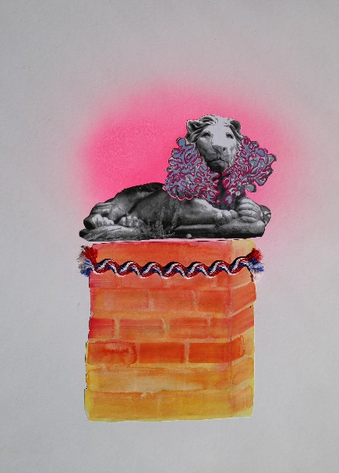
Figure 1: Sarah Horton. (2019). Hilly Plantation: Detached house, parking for two cars. Spray paint, gouache, photocopy and fabric on paper. © Sarah Horton
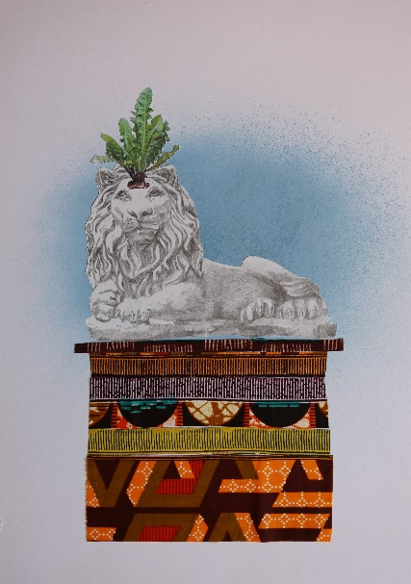
Figure 2: Sarah Horton. (2019). Hilly Plantation: Detached house with private rear garden. Gouache, fabric, pencil and photograph on paper. © Sarah Horton

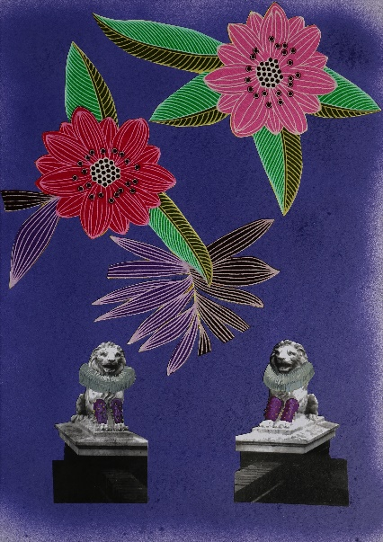
Figure 3: Sarah Horton. (2019). Constitution Hill: Period property with south-facing garden. Spray paint, gouache, fabric and photocopies on paper. © Sarah Horton

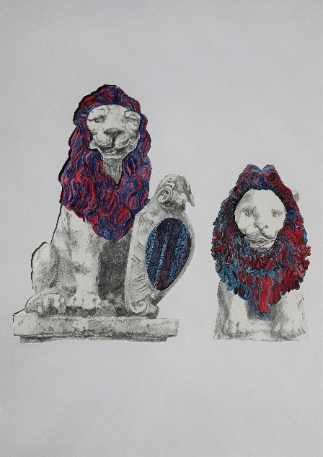
Figure 4: Sarah Horton. (2019). Green Lane North: Detached house, stunning views. Pencil and gouache on paper. © Sarah Horton

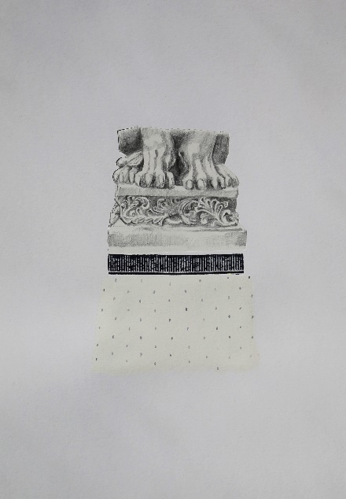
Figure 5: Sarah Horton. (2019). Gipsy Lane: End of terrace with on road parking. Gouache, fabric and pencil on paper. © Sarah Horton

