Hard Graft? The Office Chair as a Site for Decorative Art Interventions

Abstract
As everyday life increasingly conflates home and work, the boundaries between the domestic and the workplace become ever more blurred. The practice-led research presented here tested the ability of decorative art interventions applied to a series of ordinary office chairs, to spotlight and critique this complex relationship. The everydayness of the chair, its familiarity and its easy comparison to the body, make it an ideal site for the ‘wearing’ of artistic interventions. This methodology is based on the fine art concept of intervention and draws on the theoretical positions of Bourdieu’s habitus (1979) and Michel de Certeau’s (1984; 1998) concept of resistance. The materials and techniques used to create these artworks have implications for identity and class, and ‘graft’ is used both as an allusion to labour and to the collage tactics adopted in these artworks. The embodied (sensual and haptic) qualities of these artworks are the features that afford them critical agency, whether through the addition of a Mickey Mouse antimacassar or a ludicrous pile of cushions. (168 words)

Keywords: art intervention; decoration; everyday; chair; office; Bourdieu; habitus; de Certeau.

Introduction
This article describes and contextualises a series of two- and three-dimensional artworks that begin with the office chair as their starting point. This work was made in order to test the extent to which decorative features used in bespoke artworks could provide a critical and questioning lens upon the relationship between home and work. Whilst the sites of my previous projects have included an industrial-scale laundry and the reception area of a large insurance firm the site under examination here was the ubiquitous office chair.

I will begin by summarising the theoretical constructs to which the work relates, primarily Pierre Bourdieu’s (1979) theory of practice and habitus, and Michel de Certeau’s (1984; 1998) concept of resistance. Ben Highmore’s assertion that collage can be used as an aesthetic tool for use in everyday contexts also informs much of the methodology within this work, the concept of collage being extended to sculptural interventions that are ‘grafted’ on to the chair. Thus, the concept of graft is used to refer both to the collage tactics applied in these artworks as well as the suggestion of labour when graft is used in the colloquial sense of the word. Further considerations of methods and materials will preface the results and analysis sections which will in turn refer back to the theoretical positions integral to the work’s creation. I will argue that the interventions are a form of graft that interrupt the reading of the office chair to create a sense of incongruency alluding to issues around work-life balance and the complexities of 21st century labour, including the home as a site of work.

Situating the research and defining its scope
As everyday life increasingly conflates home and work, the boundaries between the domestic and the workplace become ever more blurred (Berardi 2009; Maharaj 2012; Crary 2013). As I write this article I am seated in my art studio, a room that doubles as an office, situated in my home. This room provides a perfect example of the way in which the boundaries between contemporary home and work life have become blurred. The office chair I’m sitting on would look out-of-place in any other room of my house but here it seems appropriate because it signifies industry as opposed to leisure. The comparison to the body is inevitable with the chair: the chair itself is even described as having ‘arms’, ‘legs’ and a ‘back’. This mirroring of the human body is one of the reasons why the chair is such a fertile site for creative practice across and between both contexts of art and design. Clive Edwards argues that chairs are able to signal a “view of collective ideas about authority and status, self-definition and identity, discipline, domination and behaviour, and comfort and relaxation” (Edwards 2011: 162) above and beyond being a place to sit. It is this persistent ability to hint at status, habits and tastes - or ‘habitus’ (more of which later) - that forms one of the main reasons why analysis of the chair is so useful to this study and why the chair is such a rich site for potential decorative art interventions.

The chair has attracted so much attention from artists partly due to its ubiquity and its rootedness within the everyday. As designer Jonathan Olivares writes “(o)ffice chairs have become ubiquitous products, sold in the millions to corporations and institutions the world over” (Olivares 2011: 17). Interest in the quotidian aspects of life generally continues to spawn a wide spread of theoretical and practical applications in the areas of sociology and art. Not only do critics acknowledge its longevity, but they also recognise that the everyday has critical potential. The everyday under discussion here is the jostling between home and the workplace, the employment of decoration, ornamentation and pattern and how these play out when used in artworks within the site of the ordinary office chair.

The decorative was used in this research to encompass the ornamental as, according to dictionary definitions, the meanings of ‘decoration’ and ‘ornament’ are difficult to separate. Many writers have attempted to elucidate the functions and significance of decoration and ornamentation (Edwards: 2011; Brett: 2005; Bloomer: 2000; Miles: 2000; Gombrich: 1978). Whilst not denying the ways in which the decorative has been used as a pejorative term, decoration is often something to be enjoyed visually, is adorned and thus venerated. Pattern and decoration can therefore equal value, and the labour or craftsmanship associated with its production has been seen to indicate a labour of devotion and dedication. The function of decoration in military uniform (as seen in medals, insignia and ribbons) denotes role, hierarchy, belonging and status, where decoration is used in the sense of both ornamentation and a bestowal of honour.

The decorative is highly pervasive: many areas of design and craft production incorporate decorative elements. The decorative can also be connective: it is often a ‘way-in’ for a potential audience to enjoy or discover ideas in art and design. The recognisable semiotics of everyday decoration are to some extent more inclusive, potentially, than some areas of fine art. The decorative, especially in relation to décor is an area of everyday experience that most would feel able to relate to or recognise. The ways that the decorative is grafted to the office chair in these sculptural interventions is a crucial part of this research.

From a survey of available literature it is clear that the analysis of domestic and work spaces, their wall and floor coverings and the types and arrangements of furniture contained within them, has provided a wealth of research arising from and influenced by disciplines that include art and design history, philosophy, sociology, material culture, anthropology and psychology. The number of artists who have made or worked with chairs is testament to the chair’s importance within the everyday and its properties akin to the body provide a useful body surrogate. In The Age of Reason made by artist Nina Saunders in 1995 the decorative is used to signify luxury and value in her adaptation of a Chesterfield chair, undermined by the addition of a huge spherical protuberance and its suggestion of discomfort and removal of the chair’s utilitarian function. The Age of Reason is ‘decorative’ but unusable (and loaded with symbolism that is not even touched upon in this discussion). This is reminiscent of the artist Mark Wentzel’s highly bloated reworking of the Eames lounger in XLounge of 2009-10.

Suggestions of luxury also abound in Turner Prize nominee Nicole Wermers’ Infrastruktur, about which Wermers speaks of the way spaces are designed strategically to provoke a reaction and the way that “physical infrastructure determines social infrastructure” (Tate Shots 2015). Her installation consists of a number of identical chairs, each with a fur coat resting on the back of it. An additional lining has been sewn into each coat which is used to hide the back rest of each chair. Here, she argues, the public space of a chair can be fleetingly claimed or ‘privatised’ through the placing of a coat on the back of it, a temporary claiming of ownership.

One of the significant aspects of design historian Penny Sparke’s Modern Interior (2008) is that it offers a thesis on the blurring of divisions between private and public interior spaces. This is important as many of the issues around status, whether in relation to class or to gender (the latter is prioritised as a focus for Sparke) pertain to the connections between the everyday interiors we live in and those we work in. The effects of industrial modernity, as most paid labour moved out of the home, caused “a significant physical, psychological and aesthetic divide between inside spaces of domestic life and those located within buildings dedicated to public activities, including work, commerce and commercial leisure” (Sparke 2008:13).

This is aptly described in the words of Walter Benjamin (1935):
(f)or the private individual, the place of dwelling is for the first time opposed to the place of work. The former constitutes itself as the interior. Its complement is the office. The private individual, who in the office has to deal with reality, needs the domestic interior to sustain him [sic] in his illusions… his living room is a box in the theater of the world. (Benjamin 1983: 167)

The division of home and work for the working-class at that time was felt very differently to those of their middle-class counterparts. Within early twentieth century office design it was management offices that were most likely to include echoes of the domestic - family photos, patterned wallpaper and decorative objects, often arranged on a mantelpiece, resembling the gentleman’s study in the middle-class home (Sparke 2008). This division was reinforced in public spaces where, according to Sparke, the distinction between working-class and middle-class designated areas was often made through the contrast of “comfortable, domesticated spaces with more utilitarian and regimented interiors, the latter emphasising the uniformity of the masses and characterised by an absence of bourgeois comfort” (Sparke 2008: 14).

In nineteenth century offices the majority of chairs were four-legged dining chairs, which were poorly suited for extended periods of sitting. According to Olivares (2011) the defining characteristics we now recognise of an office chair – adjustable features, casters, a mechanism allowing movement – all appeared on different chairs during the 1840s and ‘50s with the first recorded use of castors being Charles Darwin’s adaptation of a William IV style armchair to allow him to move more easily between his specimens (Olivares 2011: 17).

From the early twentieth century until the late 1990s reflections of hierarchy and status were evident in the design of office chairs such that sumptuous materials, a more elaborate movement mechanism and a larger base were used only for those with higher status. Designers would create a suite of up to five different designs to indicate distinction within the ranks. (See for example, Frank Lloyd Wright’s designs for the 1956 Price Tower in Oklahoma, or the 1979-80 ‘Diffrient’ series for Knoll which had Executive, Advanced Management, and Basic Operational models.) Olivares argues that since the personal computer became more prevalent in the offices of the 1980s these distinctions have become eroded within office chair design arguing that the Aeron Chair of 1994, which was specifically developed around postures for computer use, offered its three sizes based only on body size rather than status. “If hierarchy is expressed in office chairs today, it is typically done with material; for executive seating, plastics and textiles are often replaced with die-cast aluminum and leather” (Olivares 2011: 19). The office chairs used in my research are typical of the Higher Education institute that I work in and are relatively inexpensive, made with a plastic frame and hard-wearing but indistinctive fabric. Like many office chairs in this environment they are efficient and fit-for-purpose but lack adornment or decorative attributes of any kind.

Parallel to lower production costs in office chair design the separation of the spheres of work and home have become increasingly attenuated and the relationship between the two ever more complicated. Globalisation, the world-wide web and a greater population of self-employed workers have seen larger numbers of people working at home and employers finding inventive and flexible ways to accommodate their employees’ complex work-life patterns (see Myerson, 2014, for example).

Taking work home that would normally be done in the office is only one of the ways in which economist Frank ‘Bifo’ Berardi (2009) and writer Jonathan Crary (2013) argue that new forms of alienation have entered our working lives. Crary describes the way employees commonly work overtime (often voluntarily) and use laptops and phones at home so they can continue working in their own time.

It is only recently that …. the modeling of one’s personal and social identity, has been reorganized to conform to the uninterrupted operation of markets, information networks, and other systems… 24/7 is a time of indifference, against which the fragility of human life is increasingly inadequate and within which sleep has no necessity or inevitability. In relation to labour, it renders plausible, even normal, the idea of working without pause, without limits.
(Crary 2013: 9-10)

Employees can feel tied to work because of ever-rising financial hardship and feel increasingly under pressure to meet targets. As digital technology becomes more mobile, Berardi argues that it is able to exploit the mind, language and emotions in ever new ways, whilst one’s own body and its interactions with others disappear behind computer screens. Writer and curator Sarat Maharaj (2012) similarly points out that the ability to check email on a mobile phone, or work at a laptop in the café lengthens the working day, making a clear divide between work and play impossible. In this sense, he argues, the worker’s mental and intellectual facilities are forever “plugged in to the assembly line”, ushering in a “deeper, more binding assimilation into work” (Maharaj 2012: 134). It is this tangled relationship between work and home life, and between labour and leisure, that was explored in the practice-based aspects of this research, and why an emphasis on a physical disruption of the office chair was important.

French sociologist Pierre Bourdieu uses a phrase that is key to this research - ‘of the body’ - when describing the ‘habitus’, his conceptualisation of class, and it is useful in the discussion around the sublimation of the body and 24/7 labour. Bourdieu uses the term habitus to describe an individual’s predispositions and demonstrates how these can position someone, and simultaneously also be shaped by, a person’s class. The habitus functions not only at the level of a person’s conscious opinions and choices but at a deeper, less conscious, embodied level, that is, relating very directly to the body and the practices of the individual that relate to physical taste, accent, posture, and so on (Bourdieu 1977 and 1979).

In a footnote to Outline of a Theory of Practice (1977) Bourdieu writes:
(t)he word disposition seems particularly suited to express what is covered by the concept of habitus (defined as a system of dispositions)…It expresses first the result of an organizing action, with a meaning close to that of words such as structure; it also designates a way of being, a habitual state (especially of the body) and, in particular, a predisposition, tendency, propensity or inclination.
(Bourdieu 1977: 214)

The individual’s behaviour exists in a dynamic relationship between the habitus on the one hand and the ‘field’ on the other, the field being any number of contexts or settings within which the individual is able to express a preference. According to Bourdieu “there are as many fields of preferences as there are fields of stylistic possibilities” (Bourdieu 1979: 226). Examples he gives include drinks, cars, holiday resorts and house and garden furnishings. A field may also be a social structure or social group, for example those associated with the arts, education, law or politics. Through the two concepts of habitus and field Bourdieu is able to theorise the complex inculcation of one to another. In the case of this research the habitus of the individual can be seen to be contrasted to the field of work via the individualism of the artworks compared to the generic qualities of the chair. The grafting of particular materials and forms onto the office chair – homely cushions, domestic furnishing fabrics and so on – are elements that disturb the field of work that is connoted through the office chair and potentially alter the perception and affect the habitus of the chair user. These physical characteristics operate on the perception of one’s own body as it might sit on or attempt to occupy these chairs.

Materials and Methods: Where practice and theory coincide
The methods employed for this research included consideration of the everyday ‘site’ of the chair, an emphasis on practice-led enquiry and collage/montage tactics. The use of non-gallery locations and in particular the chair as a ‘site’ led to a close examination of the definition of site-specific art. Robert Irwin (1985) described four categories of the site-related: site dominant, site-adjusted, site-specific and the site-conditioned/determined, all of which place the artwork and the site within different relationships to each other. In the latter category, site-conditioned/determined, he described the making of the artwork as drawing all its cues from the site, requiring what he describes as a “hands-on” reading of it. My analysis of the office chair affected how the artworks were made and with what materials. Irwin describes this process more fully as identifying the “aesthetic sensibility, levels and kinds of physicality, gesture, dimensions, materials, kind and level of finish, details, etc.; whether the response should be monumental or ephemeral, aggressive or gentle, useful or useless, sculptural [or] architectural” (Irwin 1985: 218). These considerations fed directly into the material and physical characteristics of the chair interventions and the collage strategies that were used to develop ideas for disrupting the office chair.

The notion of ‘practice’ took on a number of significant aspects. Firstly, there was art practice in the physical or ‘material’ sense of the creation, installation and display of artefacts and images. Secondly, there was the practice of a worker and the multifarious activities undertaken in the role of the artist that do not always relate directly to the making of the artwork – the job of communicating or negotiating for example. Thirdly, practice refers to the theoretical positioning of praxis – the idea that practice can be used to mediate theoretical positions as lived experience, and fourthly, that practices are activities or ‘tactics’ that can be deployed in relation to everyday experience.

In The Practice of Everyday Life (1984) Michel de Certeau acknowledged the prominence Bourdieu ascribed to practice when he wrote that “practices shape the opaque reality out of which a theoretical question can arise beyond the frontiers of any discipline” (de Certeau 1984: 51). De Certeau’s analyses are based on observations of everyday life and the ways in which individuals demonstrate agency or “resistance” through intervening with the structures and routines that frame our everyday activities. De Certeau advocates and champions the tactics that individuals use to alter, deflect or improvise with the materials that are at hand. He and his colleagues describe this range of activities in many ways: as ruses, as bricolage, as tactics and even as an ”antidiscipline” (de Certeau 1984: xiii - xvix). Rather than presenting a direct opposition to power, this form of resistance offers a broader, “pluralized” account of powers:

(r)oom remains for micro inventions, for the practice of reasoned differences, to resist with a sweet obstinacy the contagion of conformism, to reinforce the network of exchanges and relations, to learn how to make one’s own choice among the tools and commodities produced by the industrial era.
(de Certeau et al 1998: 188)

My argument is that these artworks offer a resistance, based on difference (and sometimes wit and antidiscipline) to the furniture (and the workplace) that hosts them. The artworks offer an act of non-conformism that present an inverse of power in the space of the office chair. These grafts can be designated tactics, resistive acts that employed decoration as a ‘guileful ruse’ (de Certeau 1984: 37) or a decorative tactic in the formal space of the chair.

Highmore builds upon the work of de Certeau in seeing the everyday as a site of “resistance, revolution and transformation” and key to his thinking is the importance of aesthetics, or the visual aspects of daily life. These aspects are particularly significant as they expand the range of meaningful elements attributable to the everyday. He goes on to say that to “treat everyday life as a realm of experience unavailable for representation or reflection is to condemn it to silence” (Highmore 2002: 21).

In the early stages of this research paper-based collages were formed to create site-related proposals, works on paper that explored ideas from the safety and expediency of the studio. “Clearly there is a huge potential for montage to generate critical forms of reading, by making contradictions and antagonisms explicit within the social realm” (Highmore 2002: 93). A collage allows for simultaneity of difference within the everyday to be represented, whilst refusing to allow these differences to be subsumed into a homogenous whole or to be turned into a resolved or meaningful unity. Instead collage offers a “bombardment of materials that resist narrative resolution…….where the disruption of one element by another challenges the authority of any one representational mode” (Highmore 2002: 95). As a strategy, therefore, collage can bring together disparate elements without either one assuming overall authority. The relationships between signifiers that generally determine our understanding of reality can be deconstructed through collage to create new contiguities, new connections and relationships. As “knowledge, rhetoric and aesthetic pleasure continuously disrupt one another, collage too becomes a way of thinking about looking and knowing” (O’Reilly in Craig 2008: 19). The hybrid objects and furniture-sculptures devised here use the juxtapositioning principle of collage to disrupt ideas of form and function in relation to the chair.

If the frisson or efficacy of collage as a technique lies in its power to bring together previously disassociated material, the placing of artworks to disrupt the environment of the chair worked in a similar way. In the case of these interventions the strangeness or otherness of the artworks provided an “edge” (Monroe 2008: 45), an entry point with which to pry apart the illusion of a space that combined, for example, the suggestion of Mickey Mouse ears with the boardroom chair (see Figure 2). In other words, in the same way that the edges of the paint or paper in a two-dimensional collage disturb the illusion of a cohesive space, recognising the ‘edge’ or otherness of these artworks is also necessary: without it they lose their ability to accentuate the estrangement between their individual properties and the characteristics of the chair. This is artwork used not in the traditional sense of adorning the office wall but with a more interrogative and interruptive purpose – to literally and metaphorically be tripped over!

The sculptural interventions described here might also be thought of as ‘grafted’ to the chair, in so much as decoration has been added to these very perfunctory objects. A graft refers to a transplant where plant or living tissue can survive through insertion into another organism or ‘host’. The artwork as it has been made for this research is grafted onto the chair and its meaning makes sense because of the peculiarities of that site. In the same way that the graft is both alien and ameliorative, the connective values of the decorative in these artworks enables this duality.

Through interventions the graft tests de Certeau’s idea of resistance to challenge the everydayness of these chairs. For both Bourdieu and de Certeau it is in the practical application of the theory as seen in the everyday actions of a person’s life that the theory is proved or exemplified. The art practice here is way to test these theories through the disruption or reimaging of furniture.

Results
The decorative components of these artworks were intended to be those that are implicitly ‘known’ from everyday domestic environments. Everyday fabrics, patterns, objects and motifs were used to signify the decorative, including specific materials such as dress fabrics, upholstery, soft furnishings and other furnishing embellishments. The specificity of these materials and the details of the artworks were crucial to the jarring of the artworks in the context of the chair. The photographs in Figure 1 are details of the piece 24/7 (seen in full in Figure 6) and reveal the elements of the decorative as well as the care that went into the decision-making and the crafting of the works.

Figures 1a and b: Sarah Horton 24/7 details. (2016) Office chair, various fabrics, wadding, zipper. (Photographs c. Horton).

The image seen in Figure 2 uses irony in a proposal for an intervention to the boardroom of a large, well-known financial institution in central London. This proposal takes as its starting point the idea of the antimacassar, the traditional function of which was to protect the arms or headrest of a chair from dirt and grime. Though in the past antimacassars would have been commonly found on sofas and armchairs they are now more likely to be used in a travel context, on planes for example. These additions in the boardroom are suggestive of epaulettes or of shoulder pads, the latter a staple of the office suit in the 1980s. There is also a strong semblance to the ears of the Disney character Mickey Mouse. The ideas of power dressing or of soaking up the sweat of one’s labours at work to keep the furniture pristine are undermined by the suggestion of a cartoon character, as well as challenging the authority of those who use the boardroom. The usually simple antimacassar plays a more active role.

Figure 2: Sarah Horton Boardroom Décor (2013). Paint on paper. 21 x 29.7cm.

Power Dressing (2016) (Figure 3) depicts a similar version of one of these pieces stretched over the back of an office chair. The detail of this piece reveals that it is embellished with small pleated ruffs around each of the ‘ears’. There are various interpretations that could be brought to this intervention. In the context of the office the Disney-like ear shapes may undermine a sense of seriousness and seniority, or even competence, a hint of being a ‘Mickey-Mouse’ institution. The ruff might suggest self-importance or simply dressing up, but in its juxtaposition with the Mickey Mouse ears the piece seems to suggest a diminution of power. Conversely, could the piece also be like the joker in the pack, or the fool that is in fact no fool at all but an observer and commentator on social power? Whichever of these ‘readings’ one chooses, they always return to a sense of incongruency.

Bourdieu argues that each field we encounter engenders a set of social behaviours adopted by individual agents and through these practices the individual develops a disposition for social action conditioned by their position in the field, for example, dominant/dominated (Bourdieu is careful to finesse and nuance these oppositions). The predispositions of the habitus, as expressed through choices of furnishing and clothing fabrics, were particularly resonant within this research. The complex relationship between the habitus and field, between the self and external influences, begins to indicate the symbiosis between home and workplace, between the domestic and sites of labour. I am suggesting that through the alteration of the work/home ‘field’ and the doxic incongruency that is implied through these chair interventions the habitus of the viewer is challenged.

Figures 3a and b: Sarah Horton Power Dressing (2016) with detail. Office chair, suedette, cotton. Overall height approximately 100cm. (Photograph c. Horton).

The intervention seen in Figure 4, Almost Every Cushion in the House, indicates a more complex and contradictory relationship between home and work. It takes the idea of the cushion used to add comfort to an office chair to an absurd extreme. Looking at the decorative fabrics of most of the cushions it is clear that these are taken from a domestic context. They are bound in place by furnishing piping made from suit material. The work reference suggested by the suit material in the piping implies that the stack of cushions is either being restricted by or, conversely, being supported by paid employment. The mismatched fabrics have been gathered from all over the house. Usually cushions are domestic ‘comfort-making’ objects, superfluous to the function of the chair, but helping to ease the relationship between the body as it sits and the furniture it sits upon. However, in this scenario, of course, comfort is impossible to achieve. The sense of authority and industriousness connoted through the office chair is undermined by the addition of the cushions, signifiers of leisure, rest or even slothfulness.

Figure 4: Sarah Horton Almost Every Cushion in the House (2016). Office chair, various fabrics, wadding, cushion pads, zippers, piping. Height approximately 200cm. (Photograph c. Horton).

Perhaps unlike the utilitarian value of these commonplace office chairs, Liam Gillick argues that the advantage offered by art is its surplus value. He writes:

(t)he surplus value that is art is not limited to its supposed novelty value but is embedded in its function as a system of awareness. [….] Art is a series of scenarios/presentations that creates new spaces for thought and critical speculation. The creation of new time values and shifted time structures actually creates new critical zones where we might find spaces of differentiation from the knowledge community.
(Gillick 2009: 70)

These particular artworks have a value that is separate to either their use or commodity value. When brought into the place of work – in this case the office chair - that surplus value (or ‘uselessness’) has been mobilised to create a new space for thought and critical speculation, a new “critical zone”. It is through their suggestion of otherness (of an alternative space for contemplation and the otherness of the artwork itself) that these artworks have potential strength.

Buried in the midst of the cushions in Almost Every Cushion in the House is a black, unadorned cushion, and another attempt to problematize the relationship between work and home. Work is necessary (usually) to sustain and support the individual financially and often emotionally and psychologically, but can also be a contaminant if the balance between work and home life is compromised. What should be a healthy and comfortable relationship is disturbed. Gill Valentine warns against a simple polarisation of the home and the workplace, arguing that the ‘ideal home’ is not as straightforward as it sounds. Romanticised as a place of recreation and relaxation, the home has been implicitly conceptualized as a separate and distinct time-space from the workplace. However, the home may be a site of paid work as well as an oppressive and isolating site of unpaid domestic work, which is still real work even if not always recognised as such (Davidoff et al 1979 and MacKenzie and Rose 1983: 159 in Valentine 1991: 77-79). Margaret Harrison was drawing attention to the issue of paid work undertaken in the home as far back as 1977 in her artwork Homeworkers, which highlights, in particular, the low rates of pay, usually for piece work, paid to women who were (and still are) most typically likely to take up such work.

Pattern and decoration have been used by many artists to contest assumptions about what constitutes the ‘feminine’, partially because of their associations with craft. In Art Hysterical Notions of Progress and Culture (1978) Valerie Jaudon and Joyce Kozloff, key figures in the 1970s Pattern and Decoration movement, highlighted the way that language in several of the basic texts of Modernism privileges “fine art above decorative art, Western art above non-Western art, men’s art above women’s art” (Jaudon and Kozloff 1978: 38). The cushions used in this intervention introduce colour and motifs not typically associated with the office. As already mentioned, the domestic interior, especially in the nineteenth century, has generally been designated a feminine domain in contrast with that of the workplace which has been traditionally seen as male (Sparke: 1995). Whilst these polarities are being blurred in today’s home and workplace, many of the influences of this way of thinking are still in evidence: one need only glance at the number of magazines aimed at women that include interior decoration articles. Here the gendered aspect of the chair’s design is contested. The covering of the neutral ‘grey’ in favour of polychromatic pattern, choices that are more likely to be accepted at home, have disruptive potential. The emphasis on surface causes the eye to linger on the piece and the variety of fabrics emphasizes the haptic, often associated with the decorative.

Loose Covers (Figure 5) depicts a collage of office chairs covered in a ‘shabby chic’ patchwork of colours taken from post-it notes. A less confrontational option than the antimacassars in Figure 2 these loose covers would form a radical alternative to the usual office greige. In Lynn Chalmers’ essay ‘Tactics at Work’ she writes of “small acts of subversion [that] suggest a refusal to repress the messy, fragmented trajectories of subjectivity in the face of constant uncertainty and change” (Hollis 2011: 126). Alternative chair coverings or ‘loose’ covers could be applied and changed at will to reinforce or recognise the ‘messiness’ or individuality of the users of the office.

Everyday practice patiently and tenaciously restores a space for play, an interval of freedom, a resistance to what is imposed (from model, a system or an order). To be able to do something is to establish distance, to defend the autonomy of what comes from one’s own personality (de Certeau, Giard and Mayol 1998: 255).

A choice of chair covers might restore an “interval of freedom” for the individual to restore and retain their individual personality in the impersonal environment of the office. Studies show that an employee’s ability to input into the design of their work space increases productivity as well as the happiness of the employee (Wiseman 1982; Myerson 2014). The somatic, affective, sensual, bodily aspects of my chair interventions are important aspects of the decorative and essential to the experience of pleasure that, according to David Brett (2005), decoration affords. They are also important in restoring psychological needs that have been shown to prompt a happier workforce (Myerson 2004; 2014).

Figure 5: Sarah Horton Loose Covers (2012). Proposals for low-cost office chairs with alternative covers. Paint and post-it notes on paper. 21 x 29.7cm.

The title of the artwork 24/7 (Figure 6) – taken in part from Crary’s quote - picks up on the claustrophobia of contemporary working conditions, whether these take place within or outside the home: this is a sculptural intervention that almost smothers the office chair. The use of everyday fabrics, some of which are dress fabrics, others more readily associated with the home, combine with the office chair to form a conflation of home and work. The indulgent silk-like material in the bottom half works in contrast with the hard-wearing denim of the upper part, making reference to the mixture of connotations that denim holds of traditional utility wear on the one hand and leisure wear on the other. The snake-like collar is akin to a ticker-tape patchwork of snatched moments, a constant sense of being time-poor. Here the domestic invades the territory of work. The flowing form of the fabric drapes onto the floor like an ink spill seeping into the carpet.

Figure 6: Sarah Horton 24/7 (2016). Office chair, various fabrics, zipper, hollowfibre filling. Approximately 100cm high x 200cm across. (Photograph c. Denise Ilie).

Like a giant denim duvet 24/7 slumps over the chair reintroducing the sleep that Crary argues is constantly depleted with today’s work practices. To my mind this over-abundance of padding also recalls the Sacco – a large, portable floor cushion, having none of the traditional attributes of a chair (legs, armrests etc,). At the time of its production in 1968 the Sacco was hailed as the precursor of a new genre of furniture. Floor cushions are, however, one of the oldest forms of seating: mentioned frequently in the inventories of palaces from the Middle Ages they were huge objects, often covered with leather. Used as a means of softening the angularity and hardness of chairs they were a symbol of luxury (Clabburn 1988: 150; Gloag 1964). In the present day the beanbag or cushion is also one of the strongest signifiers of leisure connected to furnishings.

Although the use of soft materials is no longer a surprise in contemporary art, the writing of art historian and critic Max Kozloff around the poetics of softness still rings true when viewing the use of the soft materials against the hardness of this corporate-looking object. Writing in the 1960s Kozloff argued that ‘softness’ had previously been disavowed in sculpture due, in part, to sculptural predecessors that emphasised the permanent, fixed and enduring qualities of, for example, stone or metal. Kozloff writes of soft sculpture that it is more likely to resemble “fatigue, deterioration or inertia. It mimes a kind of surrender to the natural condition that pulls bodies down…. And regardless of how abstract a soft sculpture is it will unavoidably evoke the human” (Kozloff 1970: 224). Soft materials are more elastic, provisional, can be squeezed and yield to touch. He argues that these qualities extend to the viewer “the possibility of a liberation from the conceit of having to dominate all material circumstances” (Kozloff 1970: 233). 24/7 and Almost Every Cushion in the House privilege a freedom from a formal and rigid aesthetic and re-assert the importance of the haptic.

The artwork Dreaming of Versailles (Figure 7) features the use of fabric over a metal frame that is delicately balanced on the seat pad of the office chair. Each tier is made from a length of fabric that has been hand-painted and then stitched to the under layer. Although the meaning of the piece is deliberately indeterminate and unfixed the title of the piece refers to the flamboyant flounces witnessed in the Palace of Versailles, or the drapes of a four-poster bed. The hand-painted fabric is made using various washes of inks, including Quink, the writing ink. A reference may be made to painting (and landscape painting particularly) on the frills where there are discernible horizon lines as well as colours that evoke the landscape: blues and ochres likely to be seen far from the office. In the same way that 24/7 contrasts the ‘relaxed’ qualities of the artworks with the formal comportment of the chair, Dreaming of Versailles sets the flounces at odds with the chair’s sterility.

Dreaming of Versailles includes an opening that exposes its internal frame. This not only reveals a different type of crafting or labour (welding) and material (steel) but also the ‘skeleton’ of the piece. It uncovers its structure, resembling the boning or corsetry of a piece of clothing or an outfit. Here the fabric could be said to become to the structure what the clothes are to the body: attached to the steel only by fabric ties, the suggestion is that this piece of fabric is detachable and replaceable. The piece could be substituted for something very different. As with Loose Covers dressing the chair is akin to grafting an identity.

Figures 7a and b: Sarah Horton Dreaming of Versailles (2016) with detail. Office chair, steel, hand-painted cotton, ink, ribbon. Size approximately 200cm height x 150cm circumference. (Photograph c. Pete Huggins).

Analysis
The hypothesis that was being tested with these artworks was whether elements of decoration, pattern and ornamentation can be used in a space where it is usually denied, to explore the complex relationship between home and work environments. How was this hypothesis interrogated through the medium of art and the language of the decorative?

The assemblages made in response to this challenge relied very much on recognizable features that can be used by or on the body, for example furniture and clothing. The viewer would have an awareness of the way these artworks would feel if touched: also, how it might respond if sat upon, how precarious it would feel to be perched on top of a huge pile of cushions, for example. Relating to Bourdieu’s notion of habitus and his associated concept of embodiment, a key component of many of these sculptural artworks is cloth, which very often has an intimate relationship to the body, to be worn or to be sat upon, for example. Somatic and haptic material qualities in the artworks remind the viewer of the importance of these alongside the cerebral and/or immaterial as well as relating to everyday experiences of decoration and décor. The embodied, anthropomorphic weight and sag of cloth at times formed an interface between clothing, soft furnishing and the neutrality of the chair.

The specific qualities of these interventions, the use of craft skills and the labour that this type of production implies, was combined with the everyday appearance of the office chairs to disturb the utilitarian status of the chair. The use of skills commonly associated with craft, such as sewing, imbued the pieces with a sense of labour, or hard, and, at times, very tedious graft which, in turn reinforced the idea of esteem and value, though not necessarily the kind of labour that typifies office work. The hand-crafted character of, for example, the painted fabric in Dreaming of Versailles emphasised the individual and unique in contrast with the mass-produced nature of the office chairs they inhabit. These crossings-over of labour carried out at work compared with the home gave as much importance to the domestic as a site of paid or unpaid work as to the public work place. Also, whilst some of the chairs were enhanced with their additions others carried a more critical approach, for example, Boardroom Décor.

Using the sculptures to establish connections between work and home, the ‘graft’ became a key conceptual and physical concept. Architect and scholar Georges Teyssot describes a graft in the medical sense as “the subtlest form of prosthesis. It links a separation of substance to functional reparation through an exchange of mutual otherness” (Teyssot 2013: 223). Can it be argued that a new species of object was created when these interventions were made to the chair, and that it is through the ‘otherness’ that this reparation occurred, both despite and because of the otherness of the grafted object and its host? The additions to the chairs could be seen as grafts that are attached through bindings, straps, or simply by enveloping the chair. The relationship might be precarious and teetering – as with the stacked cushions in Almost Every Cushion in the House – or a more stable, if smothering, structure as seen in 24/7. In a sense these are parasites that feed off the association with the chair, disarming, occasionally enhancing, its function.

Teyssot asks his reader to consider the interaction between framework and prosthesis: “frame as extension and projection of instrumentality, prosthesis as a new form of hospitality” from which arise the concepts of “hostility, unusualness, discomfort, alienation and the uncanny. Indeed prosthesis, like a graft or transplant, can be simultaneously hospitable and hostile. It vacillates between these two poles – hospes and hostis, guest and enemy” (Teyssot 2013: 245). Such is the case where artworks rely on their host environment for their place and meaning. They are both ‘hospes’ and ‘hostis’, guest and enemy. The graft is also another way of writing about collage, of the use of opposing or different components to create a spark that can only be created by these tensions. One of the key meanings of ornament, or applied decoration, comes from the Latin word ‘ornere’, meaning ‘to fit out’ or ‘complete’. Brett explores this idea of completion or satisfying a lack (Brett 2005: 264), arguing that it is often an essential characteristic and benefit of decoration that it completes the appearance of, for example, a building or décor. Brett writes of the hierarchy of the decorative as received ideas that are heavily embedded in notions of expense, status, laboriousness and the command of resources: “as such they are part of the social history and social evaluation of ornament” (Brett 2005: 220). Ornament is linked heavily to craft and to repetitive and skilled labour. The sense of the word graft is inherent in the processes used to create these pieces. The techniques used to craft these artworks were time-consuming and tiring: they embodied a sense of laboriousness.

Conclusion
The everydayness of the chair, its familiarity and its easy comparison to the body, make it an ideal site for the ‘wearing’ of artistic interventions. If, as Bourdieu described, ‘doxa’ is the state of harmony between a person’s habitus and field within which they live and work, deploying the tactics of disrupting and grafting made use of playful and sometimes ironic gestures that disturbed this doxic congruency. The main value offered by theories of the everyday is that rather than presenting the individual as a ‘dupe’ of an overarching ideology s/he can act out a spirit of resistance. This may be done not necessarily through heroic gestures but through acts of displacement or intervention. The interventionist tactics here played a direct role in disrupting the neutrality of these office chairs by giving them a specific context to be played off against, seen as both an extension and surrogate of the body. The artworks acted as clothing for the office chairs and the ‘wearing’ of these emphasized the contrast between the mass-production of the office chair and the individuality of the sculptures and, by association, the individuality of the persons who have worked at these chairs.

7615 words (with captions and minus abstract)

References
Berardi, F. B. (2009) The Soul at Work: From Alienation to Autonomy. Massachusetts: MIT Press.
Bourdieu, P. (1977) Outline of a Theory of Practice translated by Nice, R. (1977). Cambridge: Cambridge University Press.
Bourdieu, P. (1979) Distinction: A Social Critique of the Judgement of Taste translated by Nice, R. (1984). London: Routledge & Kegan Paul Ltd.
Brett, D. (2005) Rethinking Decoration; Pleasure and Ideology in the Visual Arts. New York: Cambridge University Press.
Bruderlin, M. (2001) Ornament and Abstraction. US: Yale University Press
Chalmers, L. (2011) ‘Tactics at Work’ in Hollis, E. (2011) Interior Tools, Interior Tactics. UK: Libri Publishing
Clabburn, P. (1988) National Trust Book of Furnishing Textiles. London: Viking
Colomina, B. Rumpfhuber, A. and Ruhs, A. (2014) The Century of the Bed. Vienna: Verlag für Modern Kunst Nurnberg.
Colomina, B. (2018) The 24/7 Bed available at https://work-body-leisure.hetnieuweinstituut.nl/247-bed (accessed 7.2.2019).
Craig, B. (2008) Collage: Assembling Contemporary Art. London: Black Dog.
Crary, J. (2013) 24/7: Late Capitalism and the Ends of Sleep. New York: Verso.
Czerwinski, M. (2009) Design Museum: Fifty Chairs that Changed the World. UK: Conran Octopus Ltd.
De Certeau, M. (1984) Practice of Everyday Life. Berkeley: University Of California Press.
De Certeau, M., Giard, L. & Mayol, P. (1998) The Practice of Everyday Life Vol. 2 Living and Cooking. Minneapolis and London: The University of Minnesota Press.
Gillick, L. (2010) The Good of Work [online] available at http://www.e-flux.com/journal/16/61277/the-good-of-work/ (accessed 27.2.2019).
Gloag, J. (1964) The Englishman’s Chair. London: George Allen and Unwin Ltd.
Highmore, B. (2002) Everyday Life Reader. London: Routledge.
Hollis, E. (2011) Interior Tools, Interior Tactics. UK: Libri Publishing.
Jaudon, V. and Kozloff J. (1978) ‘Art Hysterical Notions of Progress and Culture’ in Heresies, 4 (1978) pp. 38-42 © Valerie Jaudon and Joyce Kozloff [online] available at http://www.joycekozloff.net/
(accessed 27.2.2019).
Kozloff, M. (1970 [1961]) ‘The Poetics of Softness’ in Renderings. London: Studio Vista Ltd.
Lefebvre, H. (1961) Critique of Everyday Life vol. 2: Foundations for a Sociology of the Everyday translated by Moore, J. (2002) London and New York: Verso.
Maharaj, S. (2012) ‘The Jobless State: Work, Global Assembly Line, Indolence’ in Widenheim, Cecilia (ed.) (2012) Work, Work, Work - a Reader on Art and Labour. Stockholm/Berlin: IASPIS/Sternberg Press.
Monroe, I. (2008) ‘Where Does One Thing End and the Next Begin?’ In Craig, B. (2008) Collage: Assembling Contemporary Art. London: Black Dog
Myerson, J. ‘After Modernism: The Contemporary Office Environment’ in McKellar, S. and Sparke, P. (eds.) (2004) Interior Design and Identity. UK: Manchester University Press
Myerson, J. and Privett, I. (2014) Life of Work: What Office Design Can Learn From the World Around Us. UK: Black Dog Publishing
Olivares, J. (2011) A Taxonomy of Office Chairs. New York and London: Phaidon Press Ltd.
Reed, C. (ed.) (1996) Not at Home: The Suppression of Domesticity in Modern Art and Architecture. London: Thames and Hudson
Sparke, P. (1995) As Long as it’s Pink: The Sexual Politics of Taste. London: Pandora.
Sparke, P. (2008) The Modern Interior. London: Reaktion
Sparke, P., Massey, A., Keeble, T. and Martin, B. (2009) Designing the Modern Interior: From the Victorians to Today. Oxford and New York: Berg
Teyssot, G. (2013) A Topology of Everyday Constellations. Cambridge Mass.: MIT Press.
Valentine, G. (1991) Social Geographies, Space and Society. Harlow, UK: Pearson Education Limited.
Wigley, M. (1995) White Walls, Designer Dresses: the Fashioning of Modern Architecture. Cambridge Mass: MIT Press
Wiseman, J. D. (1982) ‘Office Design and Evaluation’ in Environment and Behaviour Vol.14 No. 3 (May 1982) p272

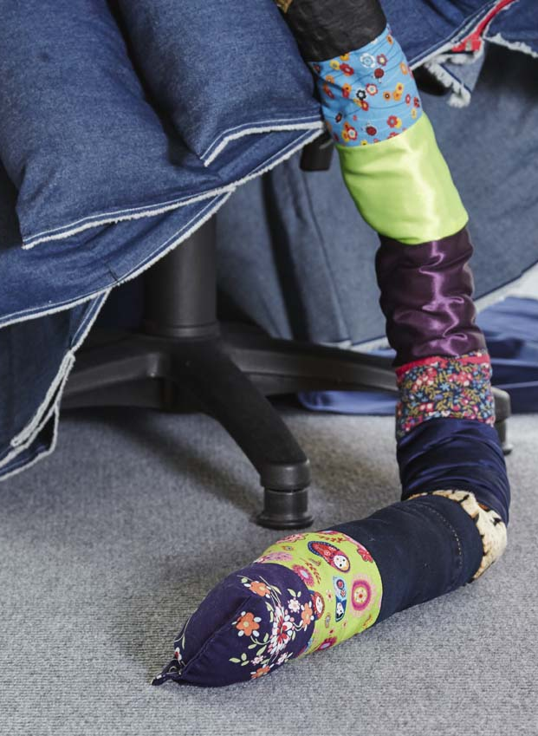 | 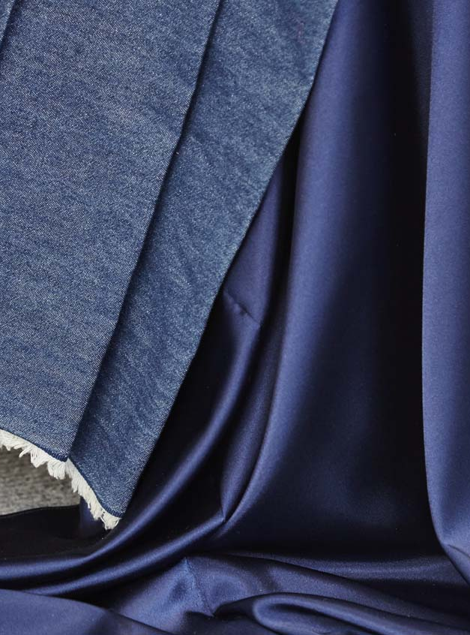

Figures 1a and b: Sarah Horton 24/7 details. (2016) Office chair, various fabrics, wadding, zipper. (Photographs c. Horton).

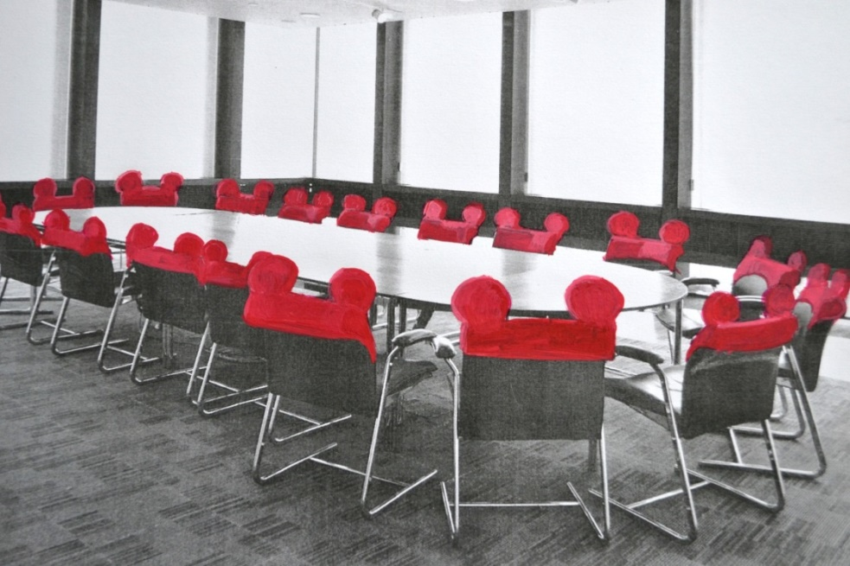
Figure 2: Sarah Horton Boardroom Décor (2013). Paint on paper. 21 x 29.7cm.

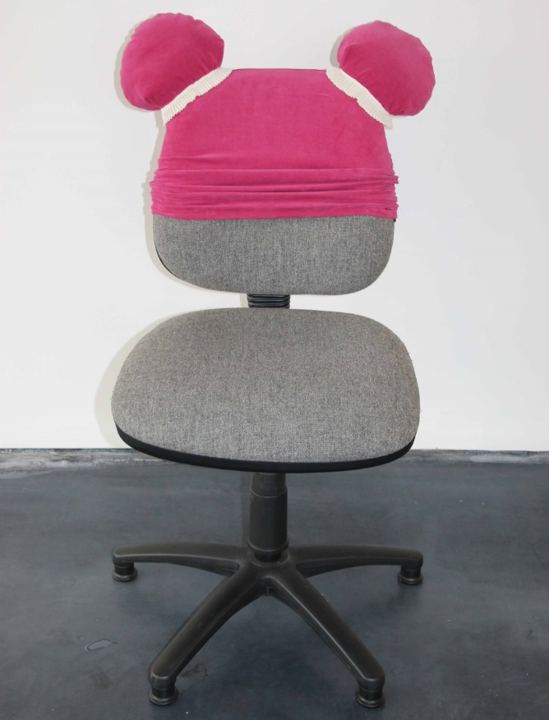 | 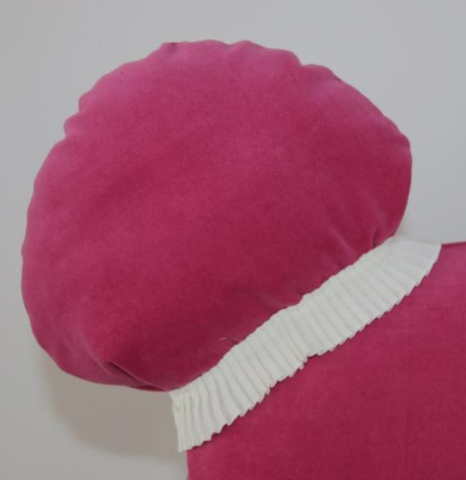

Figures 3a and b: Sarah Horton Power Dressing (2016) with detail. Office chair, suedette, cotton. Overall height approximately 100cm. (Photograph c. Horton).

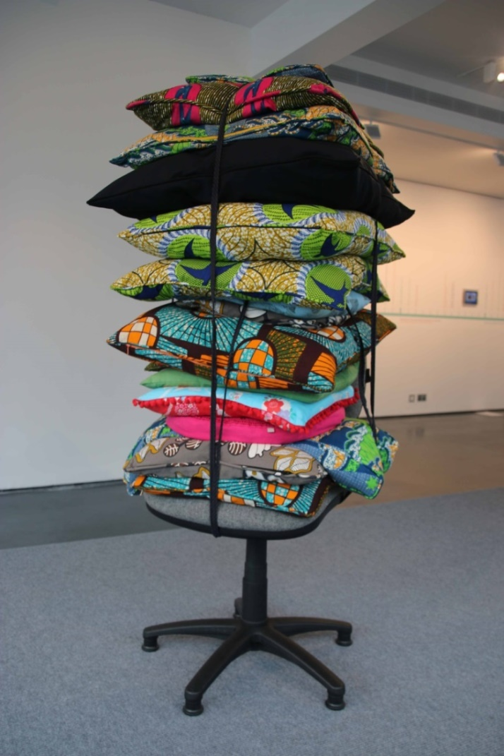
Figure 4: Sarah Horton Almost Every Cushion in the House (2016). Office chair, various fabrics, wadding, cushion pads, zippers, piping. Height approximately 200cm. (Photograph c. Horton).

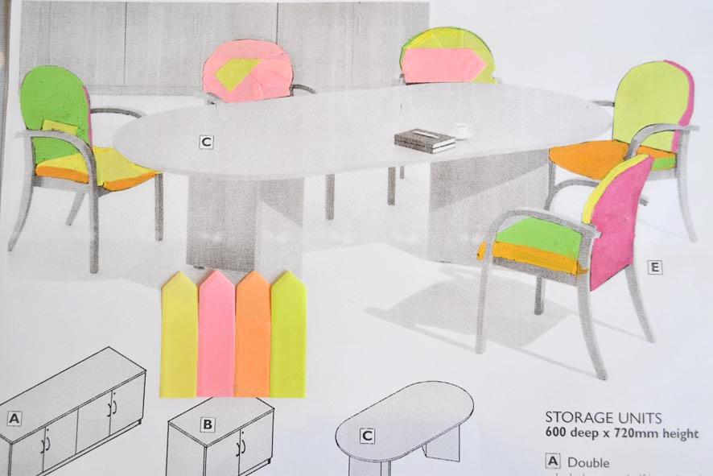
Figure 5: Sarah Horton Loose Covers (2012). Proposals for low-cost office chairs with alternative covers. Paint and post-it notes on paper. 21 x 29.7cm.

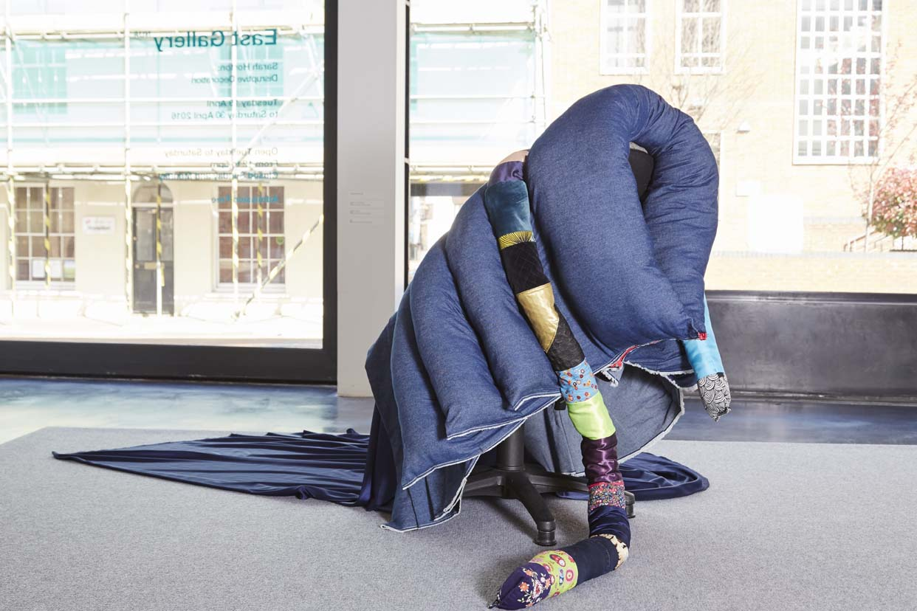
Figure 6: Sarah Horton 24/7 (2016). Office chair, various fabrics, zipper, hollowfibre filling. Approximately 100cm high x 200cm across. (Photograph c. Denise Ilie).

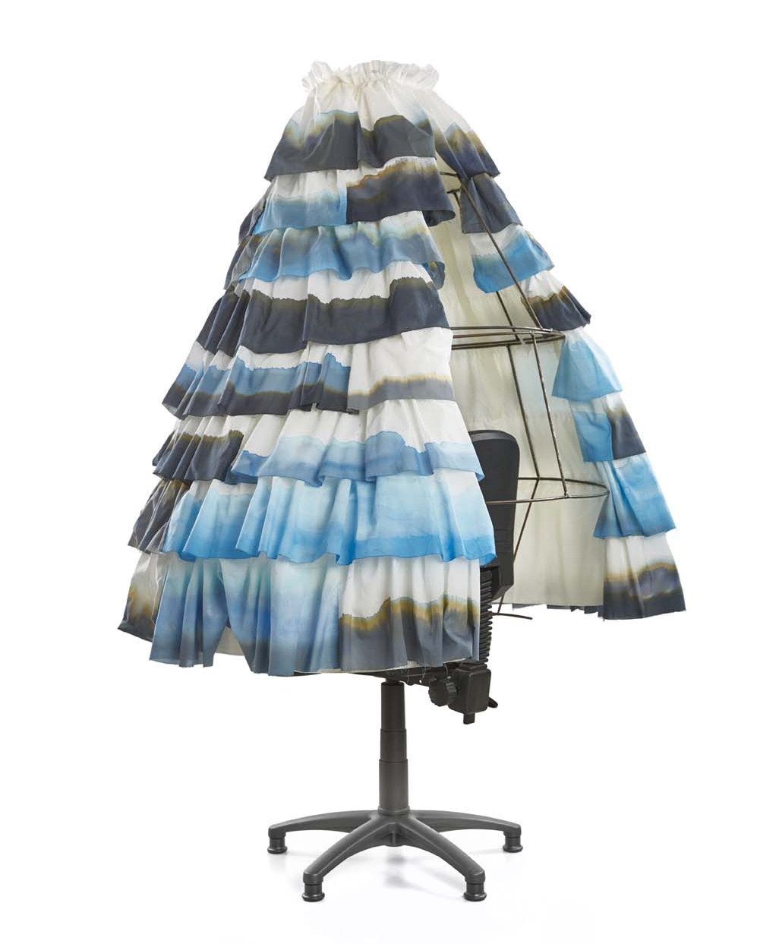 | 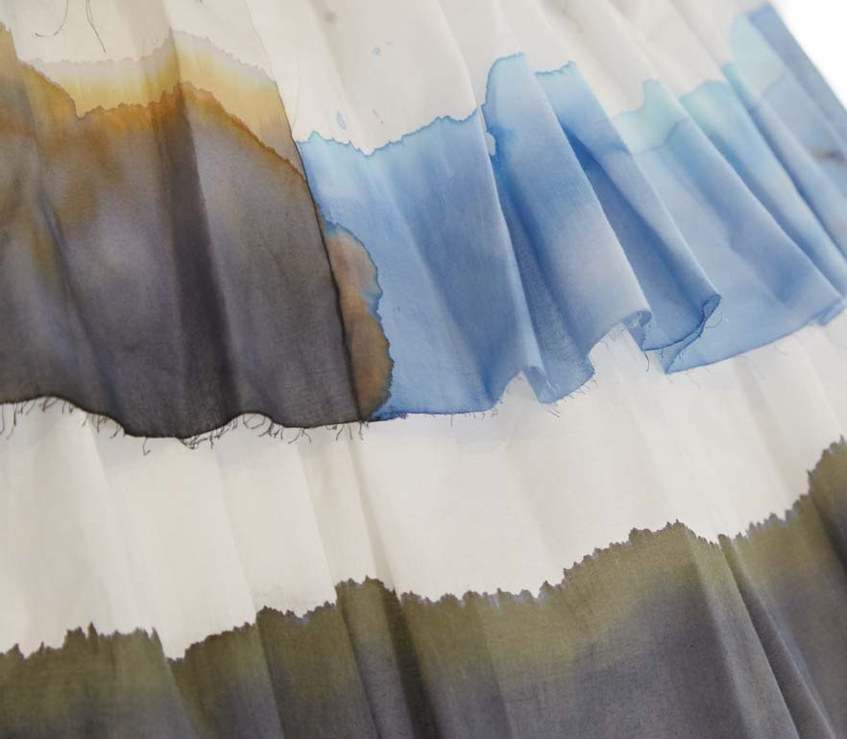

Figures 7a and b: Sarah Horton Dreaming of Versailles (2016) with detail. Office chair, steel, hand-painted cotton, ink, ribbon. Size approximately 200cm height x 150cm circumference. (Photograph c. Pete Huggins).

Figure Captions

Figures 1a and b: Sarah Horton 24/7 details. (2016) Office chair, various fabrics, wadding, zipper. (Photographs c. Horton).
Figure 2: Sarah Horton Boardroom Décor (2013). Paint on paper. 21 x 29.7cm.
Figures 3a and b: Sarah Horton Power Dressing (2016) with detail. Office chair, suedette, cotton. Overall height approximately 100cm. (Photograph c. Horton).
Figure 4: Sarah Horton Almost Every Cushion in the House (2016). Office chair, various fabrics, wadding, cushion pads, zippers, piping. Height approximately 200cm. (Photograph c. Horton).
Figure 5: Sarah Horton Loose Covers (2012). Proposals for low-cost office chairs with alternative covers. Paint and post-it notes on paper. 21 x 29.7cm.
Figure 6: Sarah Horton 24/7 (2016). Office chair, various fabrics, zipper, hollowfibre filling. Approximately 100cm high x 200cm across. (Photograph c. Denise Ilie).
Figures 7a and b: Sarah Horton Dreaming of Versailles (2016) with detail. Office chair, steel, hand-painted cotton, ink, ribbon. Size approximately 200cm height x 150cm circumference. (Photograph c. Pete Huggins).

Recent attention has also been given to the bed as a further site in which the activities of work and leisure are increasingly mixed as untethered working practices and technology are so widespread (Colomina 2014, 2018). However, whilst the bed might be used at home it is less likely to be seen at work (for the time being at least!) whereas the office chair more readily represents both spheres.
Other artists that have made direct use of the chair include Pablo Reinoso, Meschac Gaba, Erwin Wurm, Jessica Jackson-Hutchens, Sarah Lucas, Angela de la Cruz, Robert and Trix Haussmann, Richard Woods and Sebastian Wrong, Franz West, Martino Gamper, Marc Camille-Chaimowicz and Julia Lohmann.
Whilst there is certainly a look within office chair design that is generally neutral (black and greige colour palette, with hard-wearing textiles) there have been exceptions. One of the earliest swivel chair designs to incorporate an injection-moulded plastic base and spine that is typical of most office chairs was the Ettore Sottsass-designed ‘Synthesis 45’ from 1971-3 (Czerwinski 2009: 76). Unlike many contemporary chairs the plastic in this was bright orange.

