Exploring the ‘penumbra of the non-verbal’: the relationship between writing and making in a practice-based Ph.D.
Sarah Horton

Word Count: 2798 (excluding References)
Image Count: 5

Bio:
Dr. Sarah Horton is an artist and lecturer. Her PhD, entitled ‘Decoration: Disrupting the workplace and challenging the work of art’ indicates an ongoing interest in the way pattern, decoration and ornament is used in fine art. She was Learning Co-ordinator for the Norwich leg of the British Art Show 8 and has exhibited nationally and internationally.

Exploring the ‘penumbra of the non-verbal’: the relationship between writing and making in a practice-based Ph.D.
Sarah Horton

Abstract

The penumbra (or shadow) of the nonverbal is a phrase taken from Sarat Maharaj’s (2009) article ‘Know-how and No-how’ in which Maharaj describes a kind of making that does not solely rely on the verbal but on what he calls the ‘sticky’, somatic and material qualities of the artwork. He argues that these qualities exist independently of the discursive side of the process. This article explores the complicated dynamic between the material, ‘sticky’ aspects of making and the various texts that were written alongside the making in my own Ph.D. How can the practical and written components work to support rather than usurp each other? I will argue that the relationship between theory (as written) and theory (as practice) form concertina-like push-and-pull tensions that each inform the other. Using Pierre Bourdieu’s concept of ‘habitus’ the material, or ‘sticky’, qualities of artworks may be seen to link to our bodily and haptic understanding of the world. This discussion has implications for anyone undertaking practice-based research who wishes to gain a deeper understanding of the theory-practice dynamic within it.

Keywords
Nonverbal, Maharaj, practice-based research, concertina, penumbra of the non-verbal.

Introduction

The penumbra (or shadow) of the nonverbal is a phrase taken from Sarat Maharaj’s (2009) article ‘Know-how and No-how’ in which Maharaj describes a kind of making that does not solely rely on the verbal but on what he calls the ‘sticky’, somatic and material qualities of the artwork. He argues that these qualities exist independently of the discursive side of the process. This article explores the complicated dynamic between the material, ‘sticky’ aspects of making and the various texts that were written alongside the making in my own Ph.D. entitled Decoration: Disrupting the Work Place and Challenging the Work of Art. How can the practical and written components work to support rather than usurp each other? I will argue that the relationship between theory (as written) and theory (as practice) form concertina-like push-and-pull tensions that each inform the other. Using Pierre Bourdieu’s concept of ‘habitus’ the material, or ‘sticky’, qualities of artworks may be seen to link to our bodily and haptic understanding of the world. This discussion has implications for anyone undertaking practice-based research who wishes to gain a deeper understanding of the theory-practice dynamic within it.

“Let’s Get Comfortable”: A Case Study
My Ph.D. proposed that site-related artworks could provide a critical lens for the examination of hierarchy and status in the workplace through their employment of decoration, ornamentation and pattern. Bespoke artworks were placed within three work-related sites - an office reception area, an industrial laundry and a series of identical office chairs within an art gallery exhibition – to test the extent to which decorative qualities could highlight, challenge and to some extent ameliorate, physical and semiological signs of status, hierarchy and alienation. This article focuses on one set of these outcomes: five sculptures placed in Aviva’s Head Office in St. Helen’s, London, collectively entitled “Let’s Get Comfortable” (Figure 1).

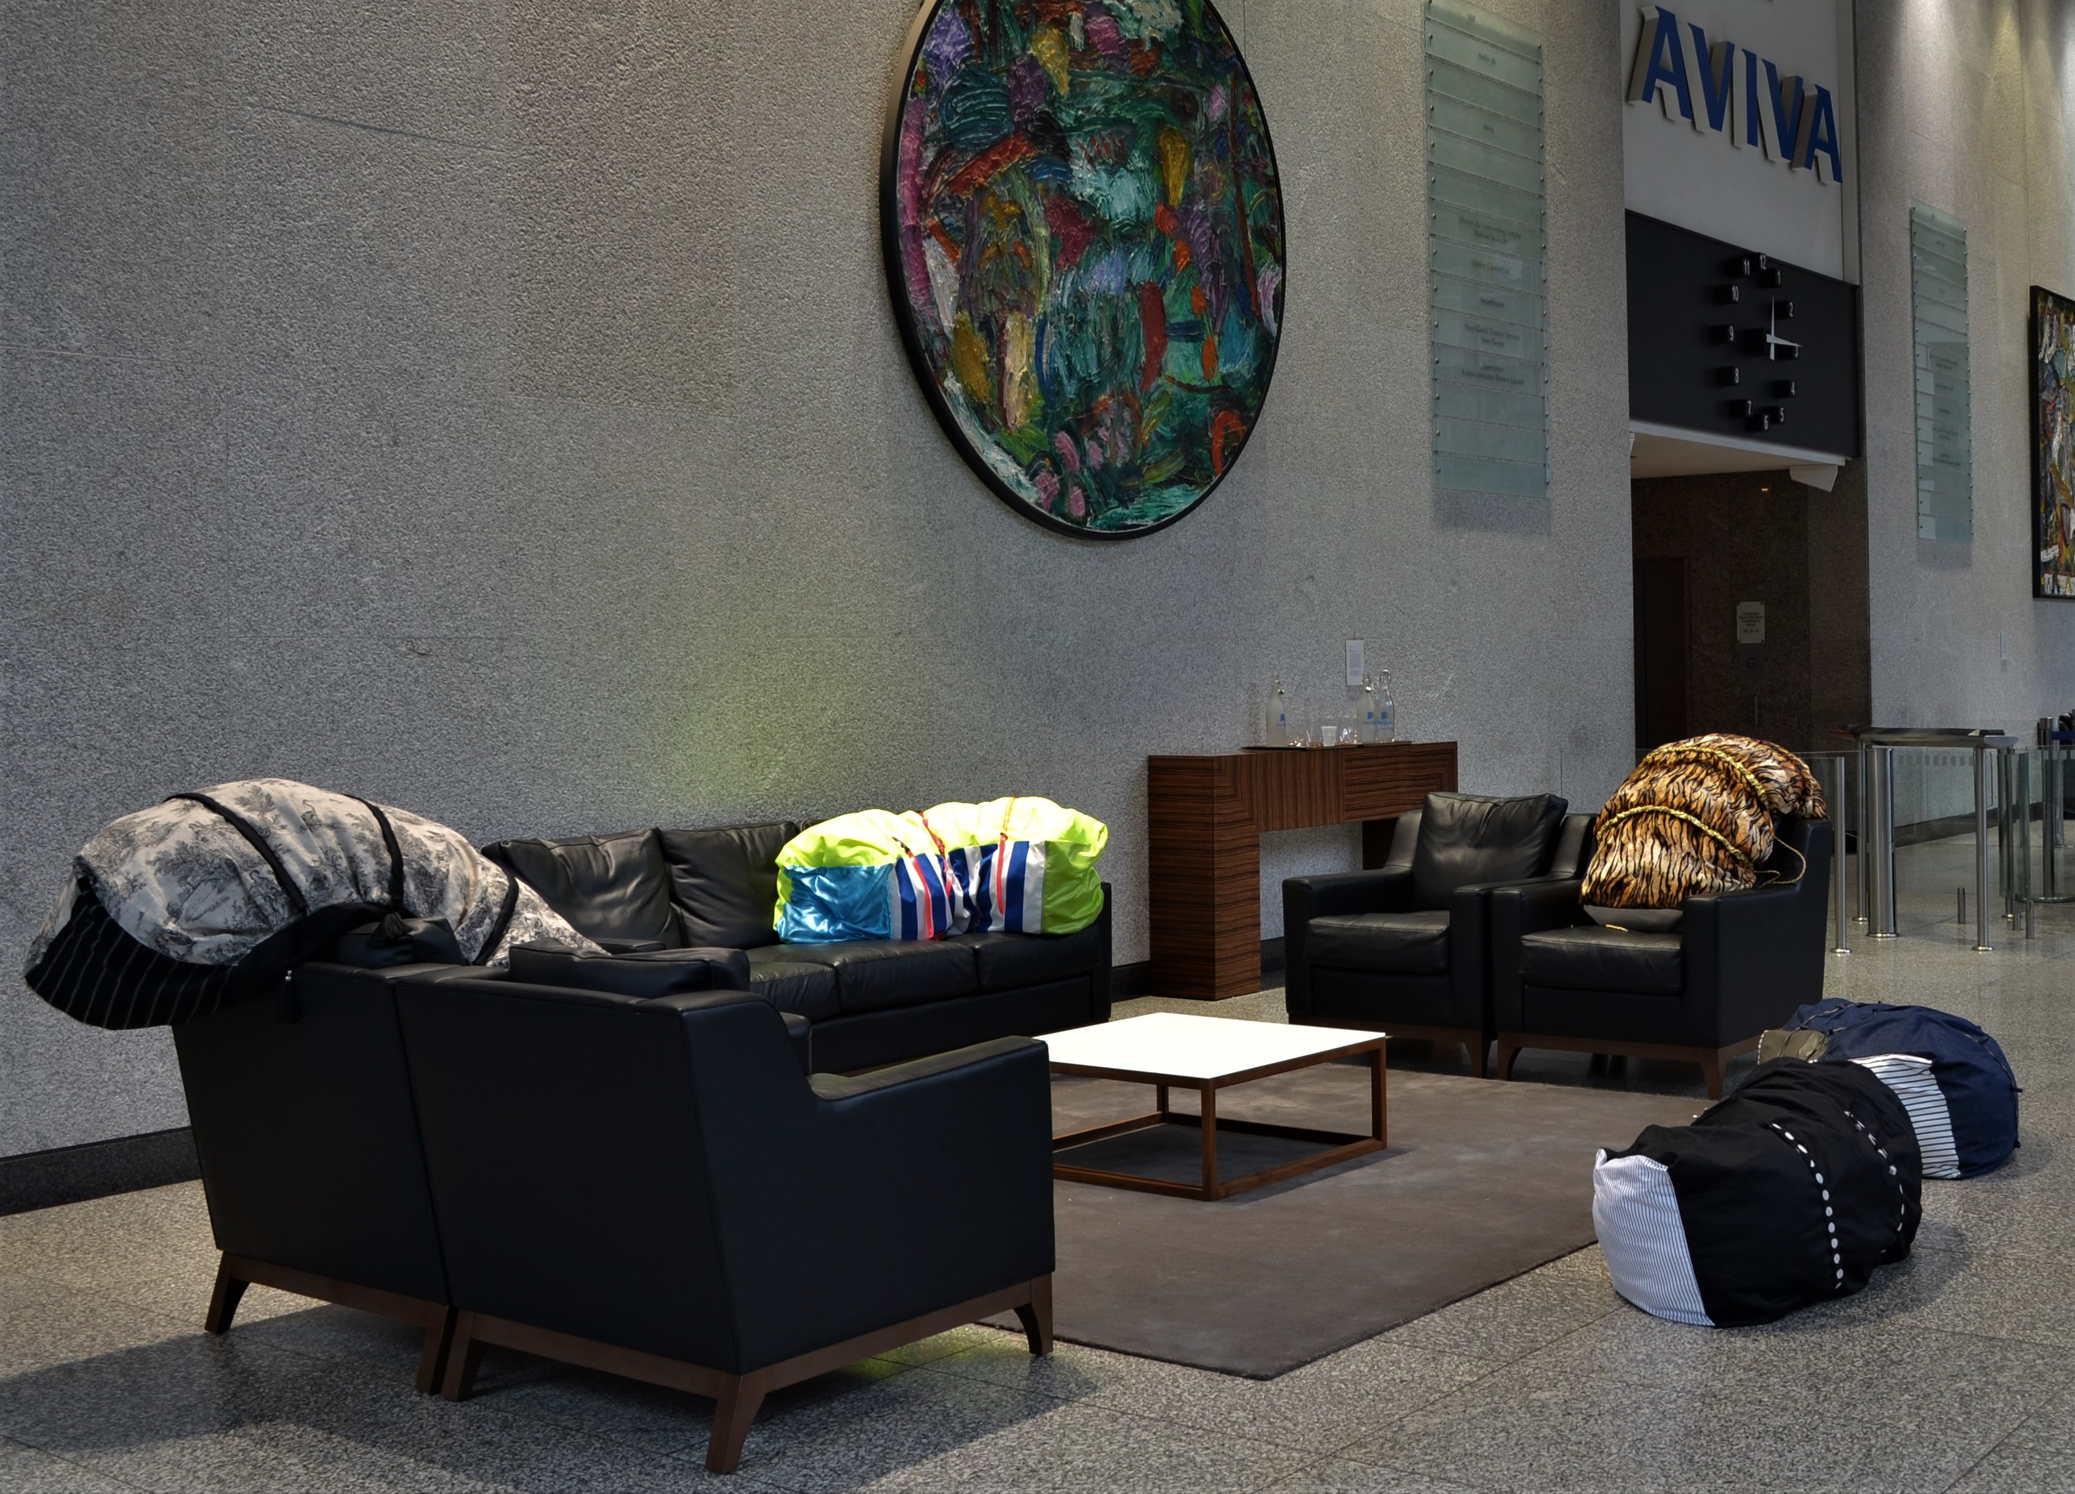

Figure 1: Sarah Horton. Installation of “Let’s get comfortable” in Aviva’s Head Office, St. Helen’s, London, 2013. Five sculptures each made of fabric, cord, cord stoppers, hollowfibre filling and additional embellishments, placed on and around the furniture in various configurations. Each piece is approx. 140cm long x 23cm depth x 23cm height. © Horton 2013.

Maharaj suggests that the ‘non-linguistic’ aspects existing in artworks are akin to non-verbal clues in communication and that both linguistic and para-linguistic clues are useful to understanding them. He argues that alongside the textual element of any work

runs its intensive non-discursive register, its seething para-discursive charge and capability – both its “pathic” and “phatic” force, its penumbra of the non-verbal, its somatic scope, its smoky atmospherics, its performative range.
(Maharaj 2009).

The pathic and phatic forces referred to by Maharaj are the physical impressions experienced and implied through the work’s appearance. The penumbra of the non-verbal is that which is difficult to put into words because it refers to experiences that are understood through the visual, tactile or somatic impression that is conveyed by the work. Each of the theoretical constructs within my Ph.D. were performed (to use Maharaj’s term) via the visual, physical and tactile properties of the works, and mediated further by their context at Aviva. For example, the cordstoppers in “Let’s get comfortable” suggest that these artworks can be manipulated and played with; we can look at the fabrics and imagine how they feel in contrast to the leather of Aviva’s sofas and the hard, cold feel of the marble floor; and, thirdly, the shape of each piece is curved, as if to suggest they might mould comfortably around the back of the sitter. Although these aspects can be described in words, the written descriptions bear only a slight approximation to the experience of seeing them in situ.

The implications provided through the setting of Aviva, a global company and one of the largest providers of insurance in the United Kingdom, creates a further set of inferences for these sculptures. The use of art interventions is advocated by Malcolm Miles as a way of making narratives visible, ‘thereby aiding a political process; or to open a space for conversation where such possibilities are generally closed, in a society in which social institutions and market forces tend towards various forms of repression’ (Miles 2000: 199). Here perhaps, as well as the ‘conversation’ that is taking place between the physical characteristics of the artworks and their surroundings, a different form of ‘text’ or discursivity may occur, a prompting of new discussions. The Aviva project combines a recognition of the space as a symbol of power or capital, a network of ‘voices’ that includes employees and visitors to the site and prevailing modes of criticality around art, design, labour and leisure.

Habitus
One of the main critical constructs used in relation to the practice here was Pierre Bourdieu’s concept of ‘habitus’ (Bourdieu 1979). Bourdieu uses the term habitus to describe an individual’s predispositions and demonstrates how these can position someone, and simultaneously also be shaped by, a person’s class.

The habitus functions not only at the level of a person’s conscious opinions and choices but at a deeper, less conscious, embodied level, that is, relating very directly to the body and the practices of the individual that pertain to physical taste, accent, posture, and so on. The idea that the habitus functions at an embodied level directly influenced the way “Let’s Get Comfortable” was made. These sculptures rely very much on recognizable, functioning materials that can be used by or on the body, for example furniture and clothing (see Figure 2). The viewer has an awareness of the way these would feel if touched, of their tactile qualities: also, how they might respond if sat upon. These somatic and haptic characteristics are the link to our physical understanding of the world as experienced through the individual habitus, and link again to Maharaj’s insistence upon the non-linguistic aspects of the work.

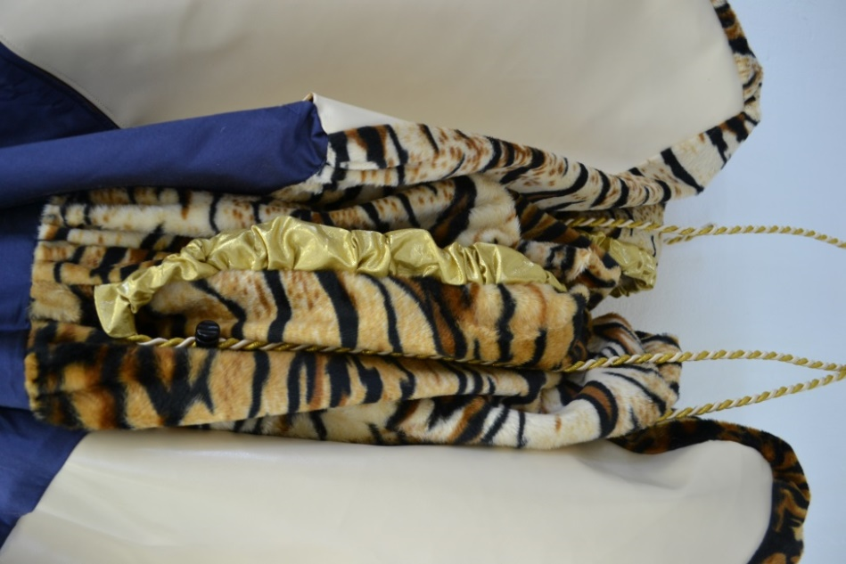 | 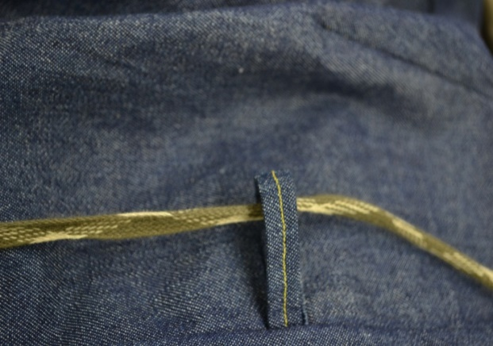
 | 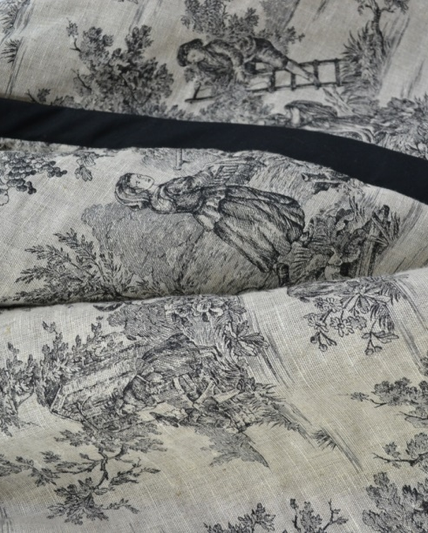
Figure 2: Sarah Horton. Details from “Let’s get comfortable” including various fabrics, cord, cordstoppers, tape, elastic. © Horton 2013.

Bourdieu states that the ordinary choices of the everyday such as furniture and clothing are particularly revealing of deep-rooted and long-standing dispositions that ‘forge the unconscious unity of a class’ (Bourdieu 1979: 77). Within the artworks for Aviva everyday fabrics, patterns and motifs were used to signify the decorative, including specific materials such as dress fabrics, suit materials, upholstery, soft furnishings and other decorative embellishments. The specificity of these materials and the details of the artworks were crucial to the jarring of the works in the context of Aviva (Figure 2). It is within these details that the references to class and taste are ‘held’ and can be recognised. It is also within these details that the paralinguistic qualities that Maharaj speaks of can be experienced. Although the fullness of their significance is articulated through the written exegesis that accompanies them, the text is not designed to ‘talk over and above’ the objects themselves.

A Practice-Theory Continuum
A guiding principle of my Ph.D., and key to the discussion here, is the idea that:

(t)he dialectic between the practical and the theoretical, between the concrete and the abstract, requires a mutual and continual testing. Philosophy is incomplete without being tested through examples, but what philosophy can offer is a ‘critical tool’ that can be used in the attempt to shatter the ‘natural’ appearance of objects and relations.
(Highmore 2002: 116).

So, rather than presenting theory and practice separately, each chapter of my thesis integrated discussion of my art practice with the historical, critical and theoretical dimensions that contextualised it. In this model the texts read were explored through the making and any text that accompanied the artwork was a way of teasing out the meanings that were more or less implicit within the work. Katie Macleod (2000), in her discussion of the artist-theorist, refers to a matrixial model where theory is made or realised through artwork. This model demonstrates the ‘intellectuality of making, which is not the same as the intellectuality of writing’ (Macleod 2000).

The final presentation of my Ph.D. comprised of two volumes. Volume One was a combination of text and images exploring the theoretical and contextual material that informed the body of artwork. This written volume was extensively illustrated using examples of the artworks made for the research as well as images of the work of other relevant artists. Volume Two was a predominantly visual account documenting the artworks made and how they were sited in each of their respective locations. As the process itself was so crucial to the making of the works a detailed visual log of the initial drawings (Figure 3), proposal drawings (Figure 4) and studio shots of work-in-progress (Figure 2) that evidenced the making process, were also included. Quotes from my Reflective Journal further revealed my thoughts at the time of making the works.

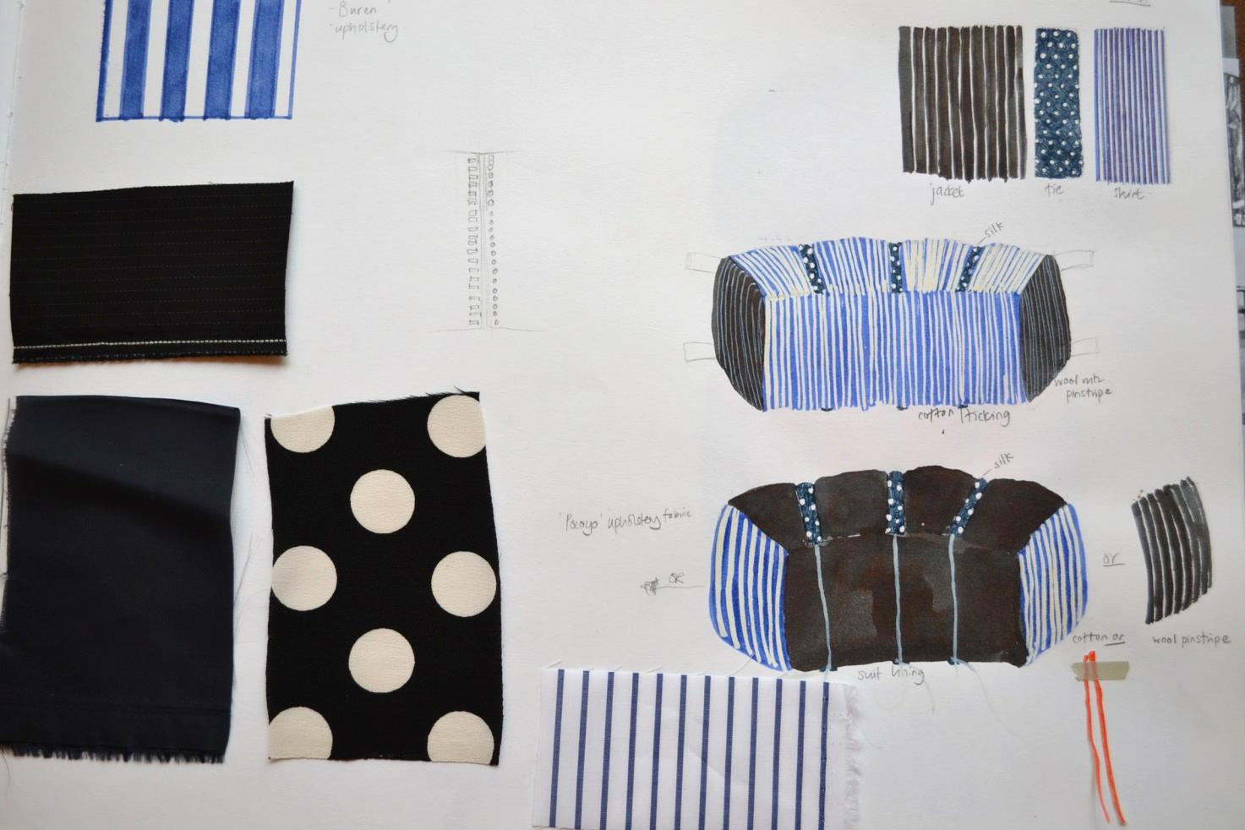
Figure 3: Sarah Horton. Drawings and fabric swatches using the suit as a starting point (2012). Pencil, inks, watercolour, tape, fabric swatches and ribbon on paper. 29.7cm x 42cm. © Horton 2013.

In “Let’s Get Comfortable” decoration was used to explore the relationship between the workplace and home and contextualised through theories of the everyday as posited by Henri Lefebvre (1961), Michel de Certeau (1984 and 1998) and Ben Highmore (2002). David Brett’s (2005) exposition of the decorative as holding both pleasurable and connective factors was also useful in describing the way in which the decorative is highly pervasive. Many areas of design and craft production incorporate decorative elements and the decorative can also be a ‘way-in’ for a potential audience to enjoy or discover ideas in art and design. However, when used out-of-place Miles speaks of decoration as something that can disrupt or disturb the ideal space:

(i)n acts of decoration …… in all the things people do themselves to state identity, the dominant city is disordered. Decoration is not a process of purification but of accretion and deconstruction, in the terms of the dominant city a kind of pollution or dirt. Endlessly diverse and always contingent, decoration undermines the ideal.
(Miles 2000: 5)

Within alternative sites, the work of art acts, according to Lefebvre, as a form of ‘play-generating-yeast’ (Lefebvre 2002: 3). Finding alternative contexts for the display of work allows for different frames of reference to affect the work, in this case using decoration as a tool for questioning issues of class and disrupting the spatial properties that support these assumptions. These placements of artwork within the work place function also as ‘tactical’ disturbances of the kind referred to by de Certeau, and to Rosalyn Deutsche’s interrogative model of site-related art (1996) where the presence of the artworks provides a direct challenge to their surroundings. In the context of site-related art the non-verbal that Maharaj refers to might also be said to include the environment in which the art is placed where the specific characteristics of the artwork’s surroundings alter or affect our perception of the work.

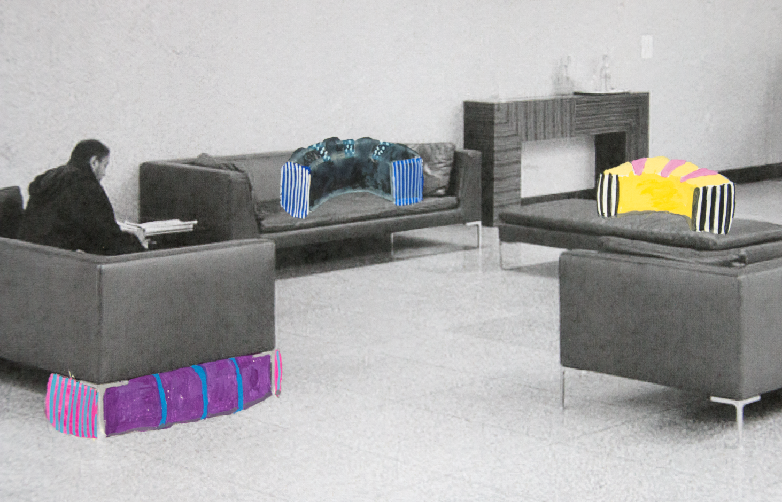
Figure 4: Sarah Horton. Proposal drawing of “Let’s get comfortable” used for pitch to Aviva staff (2012). Gouache and watercolour on photocopy. 29.7 x 42cm. © Horton 2013.

I would argue that in this relationship the areas of theory, as espoused through the text, and the theory implied in the practice can be seen to be points along a continuum, rather than being oppositionally positioned to practice. In his Dialectical Materialism of 1939 Lefebvre recognized in the model of thesis, antithesis and synthesis ‘the potential to transcend both ideological theory and social practice, hinting at a resolution of these habitual oppositions through praxis’ (Cummings and Lewandowska 2006: 413). For Marx, praxis is the way that theory becomes part of lived experience ‘where an idea ceases to be an abstract concept and becomes an everyday reality’ (ibid).

Thus, it is entirely feasible that ideas can be seen as embedded through everyday and/or artistic practices. The function of the written Ph.D. thesis is to tease out and articulate some of these ideas in textual form. It is interesting that we talk about how works of art can be ‘read’ as they become an alternative form of text in themselves, and how words can provide ‘anchorage’ (Barthes 1977: 39) to help fix the many potential meanings or signifiers within an image. So, whilst the paralinguistic aspects that Maharaj refers to are less easy to verbalise, the written accompaniment can sometimes provide a short-hand or summary of some of the theoretical tenets of the work. This is part of the concertina effect where although we might refer to a text to glean more understanding of the work of art it is the final encounter with the work itself that confirms or denies this textual reading. In many cases, especially where the placement of work in a specific location has affected how the artist has configured the characteristics of the artwork, there may be aspects of it that can only fully be realised through our physical encounter with it in situ. In the case of “Let’s get comfortable” a specific form of writing helped to understand and elucidate these physical attributes during their construction – the Reflective Journal.

Reflective Text
Students at many levels of education are expected to provide written reflection on their work, and critical reflection was found to be crucial in illuminating the relationship between theoretical positions and making within my Ph.D. Reflective practice or ‘reflection-in-action’ (Schön 1983) is a means of deconstructing the relationship between so-called ‘academic’ and practice-based knowledge, and can reveal technical, practical and critical engagement. Reflection on the practice-based elements of my research was undertaken through documenting ongoing work-in-progress photographically, testing through exhibition, daily or weekly written journal entries and through the writing of the thesis. What became clear to me is the way that the often dichotomized relationship between theory and practice is in fact a highly complex process.

The Reflective Journal interrupted the process of making in a constructive way, prompting me to pause and address the actuality of what was being made. For example, recording the work as it was being made exposed aspects of it that became obscured or hidden in its final version or in subsequent iterations of it. Often the simple process of describing the work acted as a trigger for the next stage or highlighted an aspect that did not serve my enquiry. It also ran parallel with the writing of the thesis, allowing for connections to the theoretical reading to be made. Here is a quote from my Reflective Journal dated January 2013:

[sculptures that look like] cushions made for the reception area of Aviva. How will these work? They are not cushions that would normally be seen here – they are mismatched with the black leather sofas and with each other. They are not for sale, so they have no value in terms of commodity or exchange. Any ‘exchange’ is in terms of an experience; they may give more or additional comfort; they may give cause for thought – why are they here? Why are they so big? Why use these fabrics? …….The [pieces] are transitory, like the people who sit with them.

Many of these questions or observations were expanded upon in Volume One of the thesis. In some cases the practice provoked the questions, but with the question of exchange and value it was the texts I was reading concurrently on Marx and the commodity that elicited this thought. This example shows the theory and practice working symbiotically within the overall research and exemplified the value of reflective practice. It also demonstrated the way in which the process of making the work, and not just the final outcomes, was itself revealing something about the research question. The quotes from the Reflective Journal were used alongside the images in Volume Two where appropriate to reinforce connections either to relevant theoretical references or the site in which the work was placed. Again, there was a switching between writing and making, made evident in the way Volume 2 was presented with text on one side of the page and images on the other (Figure 5).

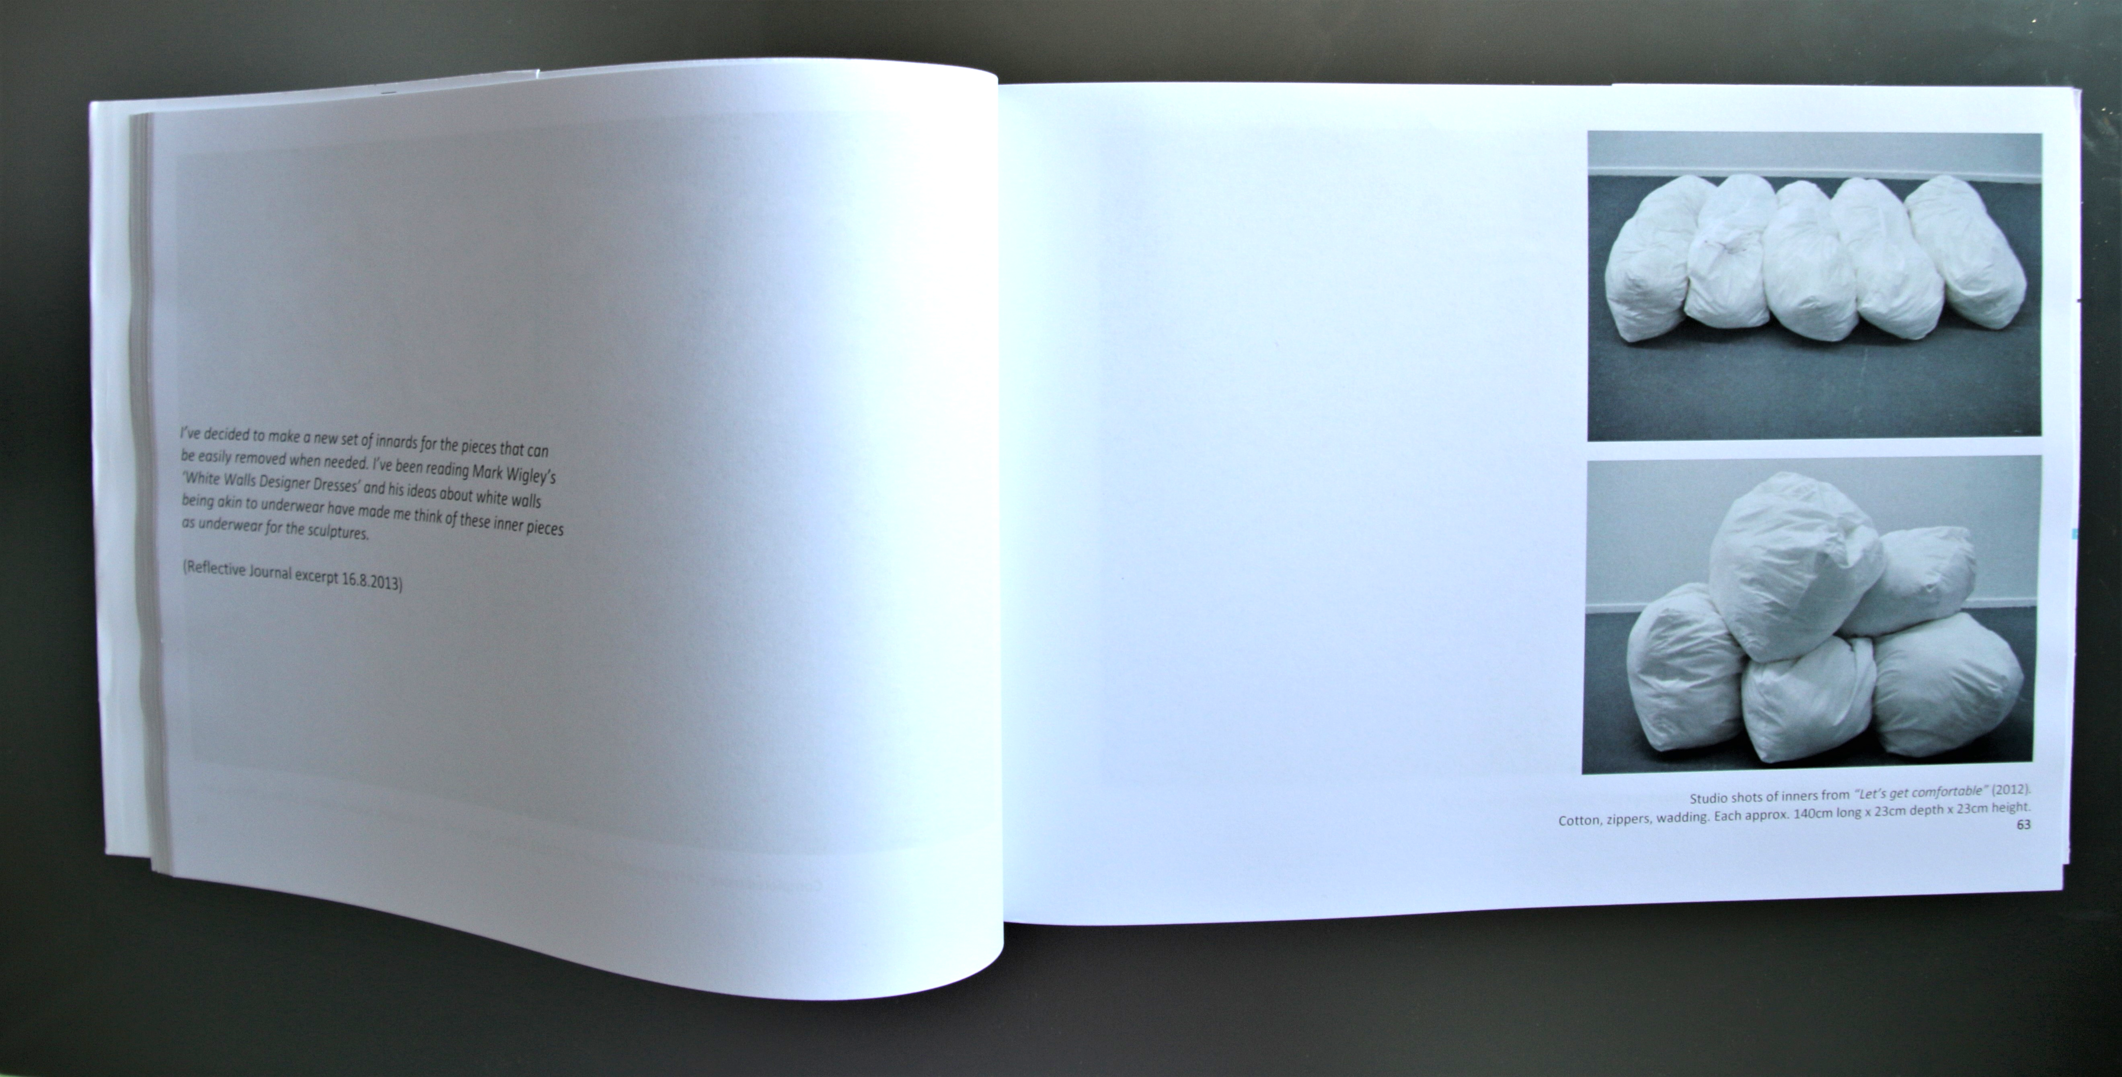
Figure 5: Volume 2 of the thesis showing a double-page spread where images of the practical work are presented on the right-hand page with its theoretical implications indicated in the Reflective Journal quotes printed on the left. © Horton 2018

Summary
In this article I have explored the positive roles that written documents can have in maintaining a concertina-like relationship between theory and making in a practice-led research project. I have argued that text and visuals should not be seen as an either/or option but as a continuum in which the text can give greater understanding to the visuals, and where the physical aspects of the works themselves, in combination with their environment, embody a language and intellectuality of their own. Through the writing of the thesis and Reflective Journal the visuals are not compromised or undermined but illuminated. Equally, theoretical understanding is gleaned through the ‘sticky’ processes of making where meaning is played out within the visual and haptic aspects of the work.

References
Barthes, Roland (1977) Image, Music, Text London: Fontana Press.
Bourdieu, Pierre (1979) Distinction: A Social Critique of the Judgement of Taste translated by Nice, R. (1984). London: Routledge & Kegan Paul Ltd.
Brett, David (2005) Rethinking Decoration; Pleasure and Ideology in the Visual Arts. New York: Cambridge University Press.
Cummings, Neil and Lewandowska, Marysia (2006) ‘A Shadow of Marx’ in Jones A. (ed.) A Companion to Contemporary Art since 1945. Oxford: Blackwell.
De Certeau, Michel (1984) Practice of Everyday Life. Berkeley: University Of California Press.
De Certeau, Michel, Giard, Luce & Mayol, Pierre (1998) The Practice of Everyday Life Vol. 2 Living and Cooking. Minneapolis and London: The University of Minnesota Press.
Deutsche, Rosalyn (1996) Evictions: Art and Spatial Politics. Cambridge Massachusetts: MIT Press.
Highmore, Ben (2002) Everyday Life Reader. London: Routledge.
Lefebvre, Henri (2009 [1939]) Dialectical Materialism. Minnesota: University of Minnesota Press.
Lefebvre, Henri (1961) Critique of Everyday Life vol. 2: Foundations for a Sociology of the Everyday translated by Moore, J. (2002) London and New York: Verso.
MacLeod, Katie (2000) ‘The functions of the written text in practice-based Ph.D. submissions’
Working Papers in Art and Design Volume 1 available at https://www.herts.ac.uk/__data/assets/pdf_file/0004/12289/WPIAAD_vol1_macleod.pdf
(accessed 29.12.2018).
Maharaj, Sarat (2009) ‘Know-How and No-How: Stopgap Notes on “Method” in Visual Art as Knowledge Production’ in ART & RESEARCH; A Journal of Ideas, Contexts and Methods Volume 2. No. 2. Spring 2009 [online] available at http://www.artandresearch.org.uk/v2n2/maharaj.html (accessed 29.12.2018).
Marx, Karl (1990 [1867]) Capital: Critique of Political Economy. UK: Penguin.
Marx, Karl (1886) Capital: A Critical Analysis of Capitalist Production translated by Moore, S. and Aveling, E. London: William Glaisher, Ltd.
Miles, Malcolm (2000) The Uses of Decoration: Essays in the Architectural Everyday. UK: John Wiley & Sons Ltd.
Schön, Donald (1983) The Reflective Practitioner: How Professionals Think in Action. US: Basic Books Inc.

Table of Illustrations
Figure 1: Sarah Horton. Installation of “Let’s get comfortable” in Aviva’s Head Office, St. Helen’s, London, 2013. Five sculptures each made of fabric, cord, cord stoppers, hollowfibre filling and additional embellishments, placed on and around the furniture in various configurations. Each piece is approx. 140cm long x 23cm depth x 23cm height. © Horton 2013.

Figure 2: Sarah Horton. Details from “Let’s get comfortable” including various fabrics, cord, cordstoppers, tape, elastic. © Horton 2013.

Figure 3: Sarah Horton. Drawings and fabric swatches using the suit as a starting point (2012). Pencil, inks, watercolour, tape, fabric swatches and ribbon on paper. 29.7cm x 42cm. © Horton 2013.

Figure 4: Sarah Horton. Proposal drawing of “Let’s get comfortable” used for pitch to Aviva staff (2012). Gouache and watercolour on photocopy. 29.7 x 42cm. © Horton 2013.

Figure 5: Volume 2 of the thesis showing a double-page spread where images of the practical work are presented on the right-hand page with its theoretical implications indicated in the Reflective Journal quotes printed on the left. © Horton 2018

